

Module Title: MSc Project
Module Code: CSIP5501

Topic: AI-Based Mobile Money Fraud Detection Using Machine Learning

Student Name: Lisa Hirpara
Student ID: P2940429
Course: M.sc Artificial Intelligence

Table of Contents
Chapter 1: Introduction 5
1.1 Background of the Study 5
1.2 Problem Statement 5
1.3 Research Aim 7
1.4 Research Objectives 7
1.5 Research Questions 8
1.6 Research Significance 8
1.7 Study Scope 8
1.8 Dissertation Structure 8
1.9 Chapter Summary 9
Chapter 2: Literature Review 10
2.1 Introduction 10
2.2 Causes and Impact of Mobile Payment Fraud 10
2.3 Types of Mobile Payment Fraud 11
2.4 Drawbacks of Machine Learning in Fraud Detection 12
2.5 Performance of Machine Learning Models 12
2.6 Advantages and Challenges of Explainable Artificial Intelligence (XAI) Techniques 13
2.7 Past Studies 14
2.8 Research Gap 17
2.9 Chapter Summary 18
Chapter 3: Research Methodology 19
3.1 Introduction and Overview of Methodology 19
3.2 Practical Component 19
3.2.1 Data Collection 19
3.2.2 Dataset Description 19
3.2.3 Stages of Exploratory Data Analysis 20
3.2.4 Data Preprocessing 21
3.2.5 Machine Learning Model Selection 22
3.2.6 Model Evaluation 23
3.2.7 Explainability Analysis 24
3.3 Research Component 24
3.3.1 Research Philosophy 24
3.3.2 Research Approach 25
3.3.3 Research Design 25
3.3.4 Data Collection 25
3.3.5 Searching Strategy 25
3.3.6 Data Analysis 26
3.4 Ethical Considerations 26
3.5 Limitations 26
3.6 Chapter Summary 27
Chapter 4: Data Analysis 28
4.1 Introduction 28
4.2 Exploratory Data Analysis 28
4.2.1 Dataset Overview 28
4.2.2 Dataset Features 29
4.2.3 Data Distribution 30
4.2.4 Data Visualisation 31
4.2.5 Correlation Analysis 35
4.2.6 Data Preprocessing 35
4.3 Comparative Analysis of ML Models 42
4.4 Secondary Thematic Analysis 52
4.4.1 Sources Listing 52
4.4.2 Theme Coding 53
4.4.3 Summary Table 53
4.4.4 Theme 1: Human and Behavioural Vulnerabilities 53
4.4.5 Theme 2: Technological and Authentication Weaknesses 54
4.4.6 Theme 3: Fraud Governance and Detection Gaps 54
4.4.7 Theme 4: Payment Ecosystem and Third-Party Risks 55
4.5 Chapter Summary 55
Chapter 5: Discussion 56
5.1 Introduction 56
5.2 Discussion and Interpretation of Results 56
5.2.1 Interpretation of Results from Machine Learning Algorithms 56
5.2.2 Discussion of Theme Analysis 57
5.3 Chapter Summary 59
Chapter 6: Conclusion and Recommendation 60
6.1 Conclusion 60
6.2 Linking with Aim and Research Questions 60
6.3 Research Limitation 61
6.4 Future Scope of Work 62
6.5 Critical Review and Reflection 63
References 66
Appendices 74
Appendix-1: Summary of Papers 74

Chapter 1: Introduction

1.1 Background of the Study
The revolution of digital payment services and mobile connectivity has made banking and money transfer seamless. At the same time, it has also elevated the risk of payment/financial fraud in the digital payment system. A report by the BioCatch, based on data of 5 continents, has informed that 350 million consumers in the year 2025 have experienced financial fraud while transferring money through the digital payment services (BioCatch, 2026). The majority of such frauds were attributed to voice phishing scams, followed by romance scams and investment scams. SMS text-based phishing scams have also increased notably. In the Indian region only, between 2020 and 2021, the total value of financial frauds in the digital payment system rose by 20% in a single year (PWC, 2022). Such increased prevalence of fraud in digital payment systems has driven the need for advanced fraud detection and prevention measures.

1.2 Problem Statement
What is the Issue?
Digital payment fraud has become a concern for both the general consumers and businesses. According to the statistics, more than 76% of the organisations across the globe experience digital payment fraud at least once in a year, which corresponds to a collective annual loss of $20-$40 billion in economic losses (ZIGRAM, 2026). Surprisingly, experts have projected a growing rate of financial losses as a result of mobile payment fraud by 19% every year (Elad and Burnett, 2026). This indicates that digital mobile payment fraud statistics are increasing every year, irrespective of regulatory measures.
In the opinion of Salim (2022, p.28), an increased rate of mobile payment frauds impacts the marketing outcomes of the organisations as well as creates legal challenges and financial drawbacks. This indicates that mobile payment frauds not only hamper the financial position of the individuals but also create negative consequences on the brand image and legal frameworks, resulting in business continuity problems. Alternatively, from a consumer perspective, mobile payment fraud affects their financial independence. Therefore, immediate resolution of the issue is needed.
Why is the issue?
The advancement of technology is a blessing as well as a curse to the people’s and organisational financial efficacy. In the opinion of Behera, Bala and Rana (2023, p.9-10), technological advancement has enabled mobile payment that supports contactless payment and safeguards humans from diseases spread through human touch. Alternatively, the technological advancements have made the fraud approaches most sophisticated. Such as the use of phishing, social engineering and other types of technologically advanced approaches that not only hamper the financial independence of the people but also impact the privacy by retrieving sensitive insights. Hence, it can be defined that the advancement of fraud approaches is the ultimate root-cause of the growing rate of incidents.
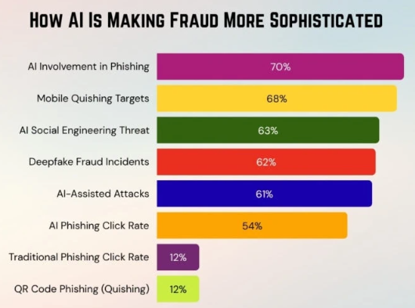
Figure 1.1: AI Involvement in Payment Frauds
(Source: Elad and Burnett, 2026)
As showcased in the figure-1, over 70% of the phishing emails used for mobile payment fraud purposes involve AI. Alternatively, 61% of the businesses have reported the involvement of AI-based social engineering attacks for mobile payment fraud (Elad and Burnett, 2026). Hence, it can be clarified that technological advancement has become the cause of such a higher amount of payment fraud. Alternatively, a lack of sophisticated payment fraud detection techniques is affecting the empowerment of the organisations or individuals to remain protected from such types of fraud.

How will this research contribute?
Machine Learning (ML) has proven efficient in preventing the prevalence of mobile payment fraud. The intelligent algorithms have the efficacy to continuously analyse the transactional data followed by identification and flagging of suspicious transactions or activities in real-time (Abdirahman et al., 2024). This informs that during the payment procedures, the ML-based models can flag and prevent fraudulent transactions to safeguard billions of dollars for the organisations.
This research will go one step further by creating an explainable AI-based fraud detection model. In particular, by comparing multiple ML-algorithms based on their accuracy and precision, the study will propose the best-performing explainable AL-model that not only flags the fraudulent transactions but will also share the explanation of the decision to support decision-making transparency of users.

1.3 Research Aim
AIM:
The research aims to perform a comparative analysis of multiple Machine-Learning-based algorithms to build the most efficient and explainable fraud detection model for the digital payment system and consumers.

1.4 Research Objectives
Objectives:
- To perform a literature review for establishing the theoretical aspect of the research in terms of the prevalence of mobile payment frauds, the drivers of payment frauds, performance & efficacy of ML-based algorithms and existing drawbacks of ML-based algorithms.
- To collect a dataset of mobile payment fraud using an online data collection platform, Kaggle.
- To perform exploratory data analysis for understanding the distribution of classes and trends in the dataset.
- To preprocess and transform the dataset based on the outcomes of the exploratory data analysis to make the dataset applicable for Machine Learning models.
- To apply Explainable AI frameworks and techniques to the models for improving the decision-making transparency of the models.
- To compare the performance of multiple Machine Learning algorithms based on performance metrics like precision, accuracy, ROC-AUC curve and others
- To perform thematic analysis using secondary data to validate the outcomes of the experimental results and evaluate the causes of mobile payment frauds.

1.5 Research Questions
RQ-1: How efficiently can a Machine Learning-based fraud detection model contribute to improving fraud detection and enhancing the mobile payment service?
Justification: The outcomes of the past research studies have not showcased consistency of ML-models in classifying mobile payment frauds accurately and precisely. As a result, understanding of the best performing model is limited. Hence, by addressing this research question, the performance of the ML-models can be evaluated, followed by the understanding of the best model for detecting and classifying fraud.
RQ-2: What are the ultimate root causes of mobile payment fraud?
Justification: As of now, the study has developed a brief understanding of the root causes of mobile payment fraud. However, to ensure the theoretical integrity of this research, an understanding of the actual root causes is essential. Hence, by addressing this research question, the theoretical foundation of this study can be established.

1.6 Research Significance
The successful outcome of this research will contribute to empowering the organisations in detecting fraudulent mobile payments before they can happen. Therefore, the research will support reducing the fraudulent mobile payment activities, enabling organisational efficacy to better manage the financial position while also maintaining brand reputation and the legal efficacy in operations.

1.7 Study Scope
The research will pursue both the theoretical and practical activities for safeguarding consumers and businesses in preventing mobile payment fraud. In terms of practical activity, the research will undertake a Machine Learning and Artificial Intelligence (AI) based fraud detection model development activity supported with the Python programming language. On the other hand, the theoretical explanations will be provided regarding the causes of mobile payment frauds, the outcomes of the frauds and challenges related to the ML-based mobile payment fraud detection models.

1.8 Dissertation Structure
Chapters | Purpose
Chapter-1: Introduction | To introduce the research area, aim, objectives and research questions.
Chapter-2: Literature Review | To perform a literature review to establish the theoretical foundation of the research, followed by the identification of the research gap.
Chapter-3: Research  Methodology | To design and develop the methodological approach of the research by clarifying data collection, data analytics, research philosophies and the Machine Learning techniques.
Chapter-4: Data Analysis | To perform a detailed analysis of the practical outcomes, followed by a thematic analysis of the theoretical aspects of the study.
Chapter-5: Discussion | To perform a systematic discussion and evaluation of the research findings and outcomes.
Chapter-6: Conclusion and Recommendation | To conclude, the research area is supported with recommendations for future research procedures.
Table 1.1: Research Structure
(Source: Self-Created)

1.9 Chapter Summary
Thus, it is being concluded that digital payment fraud is now the most critical challenge for both consumers and businesses. Statistically, more than 76% of the organisations across the globe have experienced digital fraud at least once in a year, which means that the prevalence of the issue has increased significantly. Building on this issue, the research aims to perform a comparative analysis of multiple Machine-Learning-based algorithms to build the most efficient and explainable fraud detection model for the digital payment system and consumers. The most essential aspect of this project is that it will propose an explainable AI model supported by explainable AI techniques like SHAP. Hence, the successful outcome of this research will contribute to empowering the organisations in detecting fraudulent mobile payments before they can happen.

Chapter 2: Literature Review

2.1 Introduction
The second chapter of this research aims to perform a detailed literature review to establish the theoretical foundation of the study. The discussions will unfold the causes and impact of mobile payment frauds, the types of mobile payment fraud, implications of machine learning models for fraud detection, performance of the machine learning models, concept and implications of explainable AI, and the outcomes of previous similar experiments. The chapter will then be concluded by discussing the research gap and the conceptual framework of the research.

2.2 Causes and Impact of Mobile Payment Fraud
The background studies have informed that mobile fraud is currently one of the most significant concerns for organisations and individuals. Sayibu et al., (2025) has performed a statistical analysis to quantify the prevalence of mobile payment fraud. The findings inform that in 70% of the mobile payment fraud, SMS/text-message is the most prevalent vector, followed by voice call frauds, phishing and smishing. In contrast, Razaq et al., (2021) informs that mobile fraud payments have increased by 50% in 2018, and since then, they have increased every year. Essentially, the account takeover approach has remained the most used approach for fraudulent mobile payment purposes, followed by fake mobile apps, malware, phishing, smishing and others. Although there is conflict between authors regarding the causes of mobile payment frauds, the common aspect is that users' or organisations' lack of awareness of the fraudulent activities makes them fall into the trap.
However, the consequences of this fraudulent activity are diverse. Behera, Bala and Rana (2023) have performed a qualitative analysis regarding the negative aspects of mobile payment. The findings inform that whenever a malicious user targets an individual for conducting payment fraud, the attacker will not be restricted to financial insights. Instead, it gains access to the entire mobile device by exploiting the vulnerabilities (e.g; weak authentication) and accesses many personal and sensitive data such as demographic data. This finding indicates that payment fraud impacts the privacy of the individuals. In contrast, the statistical analysis by Muoghalu, Okonkwo and Ananwude (2018) informs that electronic banking frauds on ATM based vulnerabilities cause a 7.44% depreciation in return on assets. Depreciation is the value expressing the operating expenses in the income statement. A depreciation on the return on assets indicates a reduced income and total assets of the businesses. Therefore, fraudulent mobile payments cause significant financial impacts. However, the primary drawback is that the statistical analysis is being organised for any type of payment fraud rather than focusing on the mobile payment fraud only. Therefore, in summary of these two studies, it can be clarified that both negative social and economic outcomes can be experienced because of the fraudulent mobile payments.

2.3 Types of Mobile Payment Fraud
Over the past few years, very few studies have been organised to evaluate mobile payment fraud. The qualitative study by Yang et al., (2022) has informed about the Relay attacks for conducting mobile payment frauds. The findings inform that based on the degree of influence and impact, relay attacks can be categorised into three forms, including distance fraud attacks, terrorist fraud attacks and the mafia fraud attacks. On the other hand, Hajek, Abedin and Sivarajah (2023) has considered the security perspectives of the payment transactions to categorise the frauds into two types, including SMS-based attacks and malware-based attacks. Extending on this perspective, Razaq et al., (2021) informs that mobile payment frauds channelised through SMSs are considered a form of advanced online social engineering scams. It exploits the human cognitive biases through false information. This indicates that social engineering attacks do not breach the technical system; instead, they impersonate the actual human actors to share accessibility data such as OTP, passwords and others to conduct the frauds.
The distance fraud attack works by reducing the message transmission time by relying on the point-of-sale (POS) terminal, which allows attackers to misrepresent the distance between the transaction device and the POS. Alternatively, in a terrorist fraud attack, two separate attackers are involved, where the first attacker relays the transaction message to the second attacker to make the merchant believe that the actual user is residing close to the POS terminal, which influences them to complete the transaction (Yang et al., 2022). In the context of a mafia fraud attack, an authentication request is initiated using malicious POS information. Hence, the common aspects of all these three types of relay attacks are that POS terminal information is manipulated to influence the merchant's approval of the transaction.
The experimental study by Akesson, Gathergood and Quispe-Torreblanca (2026) has further informed about the Authorised Push Payment (APP) fraud for mobile payment services. The findings inform that APP frauds differ from traditional frauds because the transactions are initiated by an authenticated account holder, but during the process, fraudsters impersonate the trusted institutions by creating emotional pressure and urgency to cause cognitive overload and suppress deliberation. As a result, user behavioural problems arise, which cause poor decisions by users to transfer money to malicious actors. Therefore, aligning with the findings by Razaq et al., (2021), it can be defined that APP frauds are also a form of social engineering because in both cases, the emotional aspects of users are tricked to get the desired results by the malicious attackers.

2.4 Drawbacks of Machine Learning in Fraud Detection
Over the past few years, several research studies have been organised to evaluate the performance of ML-based algorithms in fraud detection for payment services or financial services. However, the process often comes with several challenges. Compagnino et al., (2025) have performed a similar type of experiment and compared the performance of deep learning, supervised and non-supervised models. However, the primary issue experienced by the author is the "black-box" nature of the ML-models. Specifically, Deep-Learning-based algorithms have showcased this nature, which affects the decision interpretability of the detection and classification outcomes. This indicates that specific models affect the transparency of the decisions and classification, which limits the learning curve of experts in understanding the rationale behind the decisions. The findings by Vijayanand and Smrithy (2025) overcome this issue. As per the authors, the black box nature of the models can be eliminated by prioritising the application of Explainable AI (XAI) techniques such as SHAPs (SHapley Additive exPlanations). This AI technique enables the models to improve the transparency of the decisions by shedding light on the influential features and justifying the decisions. Therefore, the black-box nature can be neutralised with AI-based techniques.

2.5 Performance of Machine Learning Models
Researchers have also performed some comparative evaluation of the ML-based algorithms for determining the best-performing model in the context of mobile payment fraud detection. Lokanan (2023) has compared the performances of logistic regression, Gradient Descent, Decision Tree and Random Forest and has found that Random Forest remains the most consistent model for accurately determining fraud. In contrast, by comparing multiple tree-based approaches including Random Forest, Decision Tree and others, Sengupta and Das (2023) have found that CatBoost remained a better-performing model for fraud detection and prevention compared to Random Forest. Hence, there is a knowledge gap in identifying and understanding the best algorithms for fraud detection.

2.6 Advantages and Challenges of Explainable Artificial Intelligence (XAI) Techniques
The previous section has identified the challenges and performance of various ML algorithms for mobile payment fraud detection. However, a critical challenge exhibited is related to the black-box nature of the ML-models. The study by Vijayanand and Smrithy (2025) informs that implication of XAI techniques into ML-models supports managing the transparency of decisions for black-box models. It ensures that AI systems are transparent and easy to interpret. Comparatively, in the case of white-box models, XAI contributes to improved trust between user and system by justifying the decisions. This indicates that XAI techniques have the efficiency to improve the decision-making transparency by providing supporting explanations. In contrast, Appani (2025) mentioned that XAI techniques go beyond decision transparency and enhance the comprehensibility of the black-box models. In particular, a collective application of the combined application of XAI and ML into the payment fraud detection model supports agility, accuracy and scalability. This informs that the application of XAI techniques supports better response of the fraud detection systems while contributing to better load management during heavy user traffic. Therefore, in summary, the XAI contributes to better system performance and decisions for fraudulent activity detection while reducing the scope of false-positive results. However, neither study has informed about the XAI techniques applied in the ML-model-based payment fraud detection systems.
The study by Mill et al., (2023) further informs that intrinsic XAI rule-learning techniques have significant implications for payment fraud models by detecting whether or not a transaction has been initiated through real accounts or cloned accounts. However, due to the technical characteristics, the XAI model needs to incorporate both the ML-model and associated explanations. Hence, every intrinsic XAI model needs to accommodate 4 essential challenges, including real-time analytics, concept drift, false positive minimisation and class imbalance management. Each of these challenges causes a prediction/detection issue for fraud detection models. For example, class imbalance contributes to biased prediction by the models by preferring dominant classes over minority classes. Therefore, accommodating all these challenges is essential for managing the accuracy and precision of fraud detection. In contrast, Carter et al., (2024) informs that the main challenge of improving the explainability of financial fraud detection models using XAI techniques is that the efficiency of the XAI techniques depends on the operational context and underlying model architecture. This means that the developed architecture and associated techniques to construct the model influence the performance of XAI techniques. For example, in the context of a boosted-tree-based model, Shapley-based attributes have significance for maintaining balanced options across the stability, fidelity and operational cost. At the same time, if the explanations prioritise the small set of dominant features, model confidence drops while performing deletion tests.
Hence, in summary, the main challenges of successfully adopting the XAI techniques for a financial fraud detection model are their dependency on the architecture of the baseline ML-model. At the same time, the applied XAI techniques also need to address challenges like real-time analytics, concept drift, false-positive rate minimisation and class imbalance management. However, the primary knowledge gap is that the findings could not inform about the specific XAI techniques for fraud detection models.

2.7 Past Studies
Over the past years, several experimental studies have been organised for financial fraud detection models. In this section, a few such studies will be explored to understand the underlying methodological aspects of each study. Hajek, Abedin and Sivarajah (2023) has performed an experimental study to develop a fraud detection model using ML-based algorithms. The study has informed about the RUS method for handling class imbalances. This method enables controlling the number of samples to be selected from the original data by maintaining a non-heuristic method. This means that RUS allows random selection of subsets from both majority classes to maintain heterogeneous data. In this way, the issue of imbalanced class distribution is eliminated. On the other hand, Silva et al., (2021) informs that the choice of clustering techniques and latent space size has an impact and influence on the performance of the models. By considering latent space dimension and the cluster numbers, the author tested whether it is possible that autoencoder-generated latent features can preserve the information for classification accuracy based on the applied algorithms, including SVM, Naïve Bayes and Random Forest. The findings indicate that SVM performed positively when the latent space dimension was maintained at 5, while Naïve Bayes achieved a better result for a dimension of 2. Surprisingly, Random Forest does not demonstrate any influence of dimensionality changes on the performance for fraud detection accuracy. Therefore, it can be defined that Random Forest and Naïve Bayes can perform well with lower dimensionality spaces, while in the case of SVM, too much compression can lead to poor performance.
The experimental study by Zhdanova et al., (2014) shares a contradictory performance by comparing the performance outcomes of Fraud Chain Detection (FCD) techniques and Machine Learning models. Although both FCD and ML showcased efficacy for precisely detecting the frauds, the authors believe that FCD is a better technique the ML. The foremost reason is that the recall and precision of the FCD-based technique were greater than those of ML. Alternatively, ML can only flag the transaction that is possibly initiated by a malicious user. But FCD goes one step beyond by detecting and organising an investigation into the fraudulent transaction. This means that ML is a time-intensive process because after flagging the transaction, the human resource carries out the investigation, while in the case of FCD, detection and analysis are both performed by the machine, leaving less effort for the human counterpart. Therefore, a contradiction exists between authors regarding the best methods for a fraud detection model.
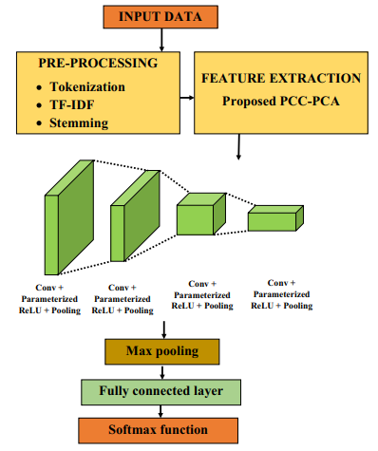
Figure 2.1: Flowchart of Methodology
(Source: Hapase and Patil, 2024)
The experimental study by Hapase and Patil (2024) gave clarity on the sequential way of performing the practical experiment and proposing the best model for CNN-based payment fraud detection. The study informs that the most essential step in developing the model is data preprocessing and transformation because ML-models cannot execute data in their original format. The relevant techniques include RF-IDF, Stemming and others (refer-to-figure-2). At the same time, feature extraction is also required for converting low-dimensional data into a high-dimensional format without losing information. Once the feature extraction is completed, the convolutional layers need to be constructed, followed by testing for efficiency and accuracy. However, the findings by Sariat et al., (2025) differ from the CNN-based method because of different algorithms. The main differences occurred after the feature engineering stage, which includes techniques of error balancing, feature selection, SMOTE for class imbalance management and then the implication of the ML-models, followed by performance evaluation based on metrics like accuracy, precision and others (refer-to-figure-3).
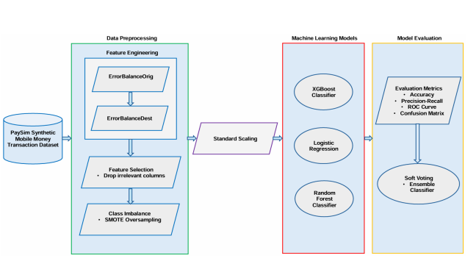
Figure 2.2: Methodology Diagram
(Source: Sariat et al., 2025)
Alternatively, the findings of the past research studies also differ from one another. Hajek, Abedin and Sivarajah (2023) has performed a comparative analysis between several ML-based supervised classifiers. The findings indicate that both XGBoost and XGBOD have demonstrated the best performance. While XGBOD has higher accuracy, XGBoost is detected with a better F1-score and precision. This indicates that XGBoost is better at classifying the minority classes but struggles with predicting the majority class instances. Alternatively, Sariat et al., (2025) has found that Random Forest (RF) has better precision than XGBoost in fraud detection systems while maintaining a significantly higher rate of accuracy. Therefore, a contradiction regarding the fraud detection model's performance exists, which affects the understanding of the best-performing model.
Hussain and Asif (2020) have further compared several other supervised ML-classifiers including Decision Table, JRip, PART, DecisionStump, J48, Naïve Bayes, IBK and LWL. The findings indicate that J48 is the best performing model in terms of accuracy, precision, F1-score and recall, while Naïve Bayes has the worst result in accurately classifying fraudulent and non-fraudulent models. On the other hand, the experimental findings by Thar and Wai (2025) inform that the hybrid model combining XGBoost and HMM has better performance than any traditional ML-model for classifying fraudulent and non-fraudulent transactions accurately.
Hence, at the end of this review, it could not be clarified which model and method should be applied because of differences among the past study results and applied methods.

2.8 Research Gap
In terms of causes and impacts of mobile payment frauds, the drawbacks of ML-based approaches, the role and challenges of explainable AI framework, different types of payment fraud and a detailed comprehension of the past studies in terms of the findings and methodologies. However, the main pattern obtained is that past studies have contradictions regarding the methods, strategies and performance of the ML-models. While Hajek, Abedin and Sivarajah (2023) has found that XGBoost and XGBOD have better accuracy and precision for fraud detection, Sariat et al., (2025) informs that Random Forest (RF) has better precision than XGBoost. Alternatively, Zhdanova et al., (2014) inform that FCD-based techniques have better performance for fraud detection than ML-based techniques. Hence, the primary knowledge gap exhibited is that there is confusion regarding the best-performing models for financial fraud detection due to differences in method and operational context. On the other hand, the studied literature could not clarify the specific XAI techniques to be applied for the fraud detection model. Hence, first-hand experiments are required to overcome this confusion and knowledge gap.

2.9 Chapter Summary
In summary, the prevalence of mobile payment fraud is increasing. 70% of the mobile payment frauds are driven by SMS/text-message scams. The frauds not only hamper the financial perspective of the organisations, but also create a risk of privacy losses because of compromised sensitive data during the fraud attacks. There are various types of mobile payment frauds present, such as relay attacks, SMS-based attacks, malware-based attacks, APP frauds and others. Although ML-models have efficiency in detecting fraud, there is a risk of the black-box nature of some models that affects the transparency of the decisions. XAI techniques have proven effective in managing the transparency issue. But the performance of the XAI techniques depends on the model architecture and operational context. With reference to the past studies, it was learnt that class imbalance, dimensionality management and others are essential methodological considerations for building an efficient fraud detection model. However, the primary gap of this review is that there is a contradiction between authors regarding the performance of the ML-models. Hence, further experiments are required to overcome this issue.

Chapter 3: Research Methodology

3.1 Introduction and Overview of Methodology
The project has used a multi–method approach by following both qualitative and quantitative techniques. Qualitative techniques are mainly applied for understanding human experience or behaviour, while quantitative methods are applied to analyse cause-and-effect relations between the variables (Xiong, 2022). Therefore, by following the qualitative methods, a secondary dataset has been collected to evaluate the root causes and drivers of mobile payment fraud. The quantitative method will be applied to perform the comparative analysis of the Machine Learning algorithms for determining the best model for fraud detection and prevention. In this quantitative approach, a dataset will be used for model training and testing purposes. Then, based on performance metrics like precision, accuracy and others, the comparative analysis of the models will be performed.

3.2 Practical Component

3.2.1 Data Collection
This research requires the collection of both qualitative and quantitative data to answer the research questions. In order to collect quantitative data, the Kaggle data source has been used, which is an open-source platform. The “Synthetic Financial Datasets For Fraud Detection” dataset has been collected from Kaggle to perform quantitative data analysis using machine learning models (Lopez-Rojas, 2017).

3.2.2 Dataset Description
The Synthetic Financial Datasets for Fraud Detection dataset includes 11 variables, which are appropriate for detecting fraud in mobile payments using machine learning algorithms. The names of the variables are:
- Step: This variable measures a unit of real-world time, where i step refers to 1 hour.
- Type: It denotes the type of transaction method used, such as cash-in, cash-out, debit, payment and transfer.
- Amount: This variable indicates the total transactional amount.
- nameOrig: It defines the name of the customer who started the transaction.
- oldbalanceOrg: This variable indicates the initial balance of the customer before the transaction.
- newbalanceOrg: This variable defines the new balance of the customer after the transaction.
- nameDest: It denotes the name of the customer who received money from the transaction.
- oldbalanceDest: It defines the initial balance of the recipient before the transaction.
- newbalanceDest: This variable indicates the final balance of the recipient after the transaction.
- isFraud: This variable identifies whether the transaction is fraudulent activity. It provides binary output in terms of 0 and 1.
- isFlaggedFraud: It defines the illegal attempt to transfer more than 200.000 in a single transaction.

3.2.3 Stages of Exploratory Data Analysis
Exploratory Data Analysis (EDA) refers to the initial step of data analysis to develop charts and graphs and perform different statistical operations on the selected dataset. EDA helps in identifying hidden patterns within the variables and understanding the relationship among variables (Ekbote, Dhanshetti and Sakhrekar, 2023). EDA performed in this research includes:
- Pie chart: As shown in below Figure 4.7, A pie chart has been developed to identify fraudulent transactions and genuine transactions.
- Bar plot: The clustered bar plot has helped in identifying the fraud occurrence based on transaction type, as shown in Figure 4.8.
- Histogram plot: A histogram plot has been developed to visualise transaction volume over time according to fraud status(see Figure 4.9).
- Box plot: A total of 5 box plots have been created to visualise transaction amount comparison between fraud and genuine transactions, and sender’s balance before the transaction based on fraud status. In addition, these also include the sender’s remaining balance after the transaction based on fraud status and the recipient’s balance before and after the transaction based on fraud status, as shown in below Figure(4.10&4.11&4.12)
- Crosstabulation: The crosstabulation has been performed to identify the relationship between the isFraud and isFlaggedFraud variables (see Figure 4.13).
- Correlation heatmap: The correlation heatmap has been developed to identify the interrelationships among each quantitative variable.
- Outlier detection and handling: In order to remove outliers and balance the dataset, the winsorization method has been used.

3.2.4 Data Preprocessing
Data preprocessing is a crucial stage in data analysis to develop machine learning models. The preprocessing stage in the development of an AI-based model for mobile money fraud detection using machine learning algorithms includes:
- Dropping unnecessary columns
The nameOrig and nameDest columns include object type variables with the names of the senders and receivers. Therefore, these two columns have been dropped to reduce complexity in machine learning model performance.
- Checking errors in sender’s balance
In order to check the reduced amount from the sender’s account is exactly same as the transaction amount in a genuine transaction, the errors are calculated. The function used to calculate the error is: errorBalanceOrig = oldbalanceOrg - amount – newbalanceOrig.
- Checking errors in the recipient’s balance
In order to check the increase in the recipient’s balance by exactly the same transaction amount in a genuine transaction, the errors are calculated. The function used to calculate the error is: errorBalanceDest = newbalanceDest - oldbalanceDest – amount.
- Calculating the transaction time in terms of the hour of the day
Since the step column provides the hour not the actual time of transaction, the value is divided by 24 and considered the remainder to identify the repeating daily patterns.
- Checking the balance in the sender’s account after the transaction
It is checked to identify whether the sender’s account is fully emptied. If the value provides 1, the sender’s account is emptied entirely and if 0, there has some balance.
- Correlation among newly calculated variables with isFraud
In order to check the relationship among the newly calculated features, the correlation function has been used.
- Checking data leakage
This step has been performed to check whether a simple transaction rule, such as transaction type CASH_OUT or TRANSFER, where newbalanceOrig = 0 and amount = oldbalanceOrgcan, identifies fraudulent transactions. It compares this rule with the actual isFraud labels using a cross-tabulation.
- Removing columns causing data leakage
The result of the data leakague showed that errorBalanceOrig and origBalanceDepleted captured this rule instead of helping the model learn real fraud patterns. Therefore, these two features were removed to avoid data leakage.
- Converting categorical columns into numerical columns
In order to convert the categorical data into numerical format, the one-hot encoding technique has been applied.
- Applying the standard scaler method
The standard scaler method has been applied to all continuous numerical features, such as original transaction, amount, new balance and error balance, so that these can be bring into a common scale.
- Selecting the features and target variable
The isFraud column has been selected as the target variable from the entire dataset and other variables have been selected as features.
- Splitting the dataset into the training and testing sets
The entire dataset has been split into an 80:20 ratio for getting training and testing datasets. The training dataset would be used to fit the machine leaning model and the testing dataset would be used to predict the model performance based on the unseen data.

3.2.5 Machine Learning Model Selection
The target variable in the mobile fraud money transaction dataset includes binary outputs. As a result, supervised machine learning algorithms have been selected to fulfill the research goals.
Logistic Regression Model
Logistic Regression is a simple machine learning algorithm which is used for performing classification tasks. Logistic Regression predicts the output of fraudulent transactions in mobile money payments in terms of a “yes” or “no” choice (Sayibu et al. 2025). Therefore, the selection of this supervised model is appropriate for this research for predicting mobile money fraud detection.

Decision Tree Classification Model
Decision Tree Classification is a popular supervised machine learning algorithm that predicts categorical labels by dividing into smaller subsets based on different feature values. Decision Tree model focuses on building a flowchart-like structure to make the final decision from the root node (Klimonová et al. 2022). As a result, this model is suitable for mobile money fraud detection using machine learning algorithms.
Random Forest Classification Model
Random Forest Classification is one of the suitable models for this research to predict fraudulent mobile payment transactions. Random Forest model combines the predictions of different decision trees to develop a single and highly accurate predictive model (Salman, Kalakech and Steiti, 2024). Therefore, this model is effective in accurately predicting mobile money fraud detection rate using machine learning algorithms.
Synthetic Minority Over-sampling Technique (SMOTE)
SMOTE method has been selected to manage data imbalance in the training dataset. SMOTE creates new artificial data points for the minority class instead of copying old data to fix data imbalance (Hairani, Widiyaningtyas and Prasetya, 2024). Therefore, this technique is appropriate to handle class imbalance for getting accurate results in mobile money fraud detection.
The selection of machine learning modes also supported by the literature of Lokanan (2023); Vijayanand and Smrithy (2025). These authors have described the importance of supervised machine learning algorithms in mobile money fraud detection. In addition, the selection of SHAP method to explain the impact of features on target variable has also been described in their studies.

3.2.6 Model Evaluation
Classification Report:
The classification report has been used to evaluate the model performance of the selected machine learning models for this research. This report includes:
- Precision: Precision can be defined as the proportion of actual positive correct predictions made by a model against positive predictions (Cabot and Ross, 2023). The formula for precision is:
Precision = True Positive (TP) / [True Positive (TP) + False Positive (FP)]
- Accuracy: Accuracy refers to the correct predictions against the total predictions by a model (Hollmann et al. 2025). The formula used for accuracy is:
Accuracy = [True Positive (TP) + True Negative (TN)] / [True Positive (TP) + True Negative (TN) + False Positive (FP) + False Negative (FN)]
- Recall: Recall performance metric measures the proportion of actual positive cases correctly identified by a machine learning model (Cabot and Ross, 2023). The recall formula is:
Recall = True Positives (TP) / [True Positive (TP) + False Negative (FN)]
- F1-Score: F1-score combines the precision and recall value of a model to get a single value using the harmonic mean (Cabot and Ross, 2023). The formula used to calculate F1-score is:
F1-Score = (Precision x Recall) / (Precision + Recall)
Confusion Matrix:
The confusion matrix is beneficial for evaluating the performance of machine learning models with predicted values and actual values. This matrix includes four factors, namely, True Positive (TP), True Negative (TN), False Positive (FP) and False Negative (FN).
ROC Curve:
ROC curve provides a visualiation for flase positive rate against the true positive rate to showcase the accuracy of any machine learning model.

3.2.7 Explainability Analysis
SHapley Additive exPlanations (SHAP) is a method, which is used to explain the impact of features in making machine learning model predictions. SHAP is effective in explaining how the decision of the model influences from its features (Wang et al. 2024). The SHAP tree explainer and SHAP summary plot functions have been used in this research to visualise the impact of the features on the target variable based on the final decision of mobile money fraud detection.

3.3 Research Component

3.3.1 Research Philosophy
The interpretivism research philosophy has been selected because the purpose of this research is to identify the root causes for mobile money fraud transactions. The interpretivism philosophy focuses on understanding social phenomena by subjective experiences and meanings rather than measurable numerical data (Acharya, 2025). Therefore, this philosophy helps in identifying the root causes for fraud transactions through mobile payments.

3.3.2 Research Approach
The inductive research approach is suitable, as this research aims to identify the root causes for mobile money fraud transactions. The inductive approach follows a bottom-up method to analyse specific observations for identifying patterns to develop insights from the results (Ding, 2023). As a result, this approach is appropriate for performing an in-depth analyse to identify the root causes for fraud transactions through mobile payments.

3.3.3 Research Design
The explanatory research design has been selected for this research to perform in-depth analysis in identifying the root causes for mobile money fraud transactions. The explanatory design focuses on cause-and-effect relationships to identify the actual reasons for any phenomenon (Benites et al. 2025). As a result, this design is suitable for assessing the reasons for which fraud transactions occur through mobile payments.

3.3.4 Data Collection
The secondary qualitative information has been collected from reputed websites such as Reuters, Banque de France and Outseer. Newspaper articles and industry reports play a significant role in collecting secondary qualitative information (Cheong et al. 2023). These websites provide the accurate information regarding the research topics on the causes of the mobile money fraudulent transactions.

3.3.5 Searching Strategy
Search element | Boolean operators and keywords
Core concept | “mobile payment fraud” AND “root causes”
Human factors | “mobile payment fraud” AND (“human behaviour” OR “social engineering”)
Technology | “mobile payment fraud” AND (“authentication weakness” OR “security vulnerability”)
Governance | “mobile payment fraud” AND (“fraud detection” OR “governance gaps”)
Ecosystem | “mobile payment fraud” AND (“third-party risk” OR “payment ecosystem”)
Table 3.1: Searching strategy using Boolean operators

3.3.6 Data Analysis
The collected qualitative data from industry sources, such as Reuters and Outseer, has been analysed through the thematic analysis to identify the root causes for mobile money fraud detection. Thematic analysis helps in identifying patterns by performing a detailed analysis with the industry reports (Ahmed et al. 2025). In the case of the identifying reasons for mobile money fraud detection, different factors can be identified using this analytical method. This thematic data analysis method also helps in analysing different reasons including human behaviours and technical weaknesses to occurring mobile money fraud payments. Therefore, it can be stated that the selection of this analytical method would be the appropriate for identifying root causes of mobile money fraud transactions.

3.4 Ethical Considerations
Ethical considerations play a significant role in mixed method of research because it includes both quantitative and qualitative data. It is ensured throughout the research that the collected quantitative data does not include any sensitive information of the customer. In addition, it is also ensured that the collected information would not be used for any purpose except this research. The qualitative information, such as industry reports, journals and articles, would not be collected from any unauthorised sources. Ethical guidelines also include giving credit to the original authors and database creators by ensuring proper citation (Kambhampati, Menon and Maini, 2023). The researcher ensures that the results do not include any bias in both qualitative and quantitative analysis. Moreover, the findings would be stored in a password-protected system, which cannot be accessed by any unauthorised person. Therefore, these ethical considerations have been followed throughout this research to ensure honesty and accuracy in the output.

3.5 Limitations
The limitations in the mixed-method research are:
- It is a time-consuming process to collect both quantitative and qualitative data. In order to overcome the identified problem, data needs to be collected in a paralleled way to gather both quantitative dataset and qualitative information.
- Data integration becomes more complex in mixed-methods research. Since data integration in a mixed-method research creates complexity, the achieved result of the quantitative models needs to be analysed based on the evaluation of qualitative information (Hall and Mansfield, 2025).
- Outputs may be contradictory from both qualitative and quantitative analysis. If outputs contradict results from quantitative and qualitative analyses, further statistical analysis using neural network should be implemented to get accurate results for aligning with qualitative results (Esna-Ashari, 2025).

3.6 Chapter Summary
This chapter described the research methods used in this study on predicting mobile money fraud transactions using machine learning models. Pragmatism philosophy, abductive approach, explanatory design and mixed-methods research strategy were used in this project. In addition, both qualitative and quantitative data were collected from proper sources. This chapter also discussed data preprocessing, exploratory data analysis, machine learning model selection, evaluation metrics, ethical guidelines and limitations of this research method.

Chapter 4: Data Analysis

4.1 Introduction
This chapter is based on interpreting the collected quantitative and qualitative data to answer the research questions for this research on the development of AI-based mobile money fraud detection using machine learning. The collected quantitative data has been analysed using the Jupyter Notebook platform, and the qualitative information has been interpreted through the thematic data analysis method. The results of exploratory data analysis, data visualisation and machine learning algorithms with SHAP explanations have been provided in this chapter.

4.2 Exploratory Data Analysis

4.2.1 Dataset Overview
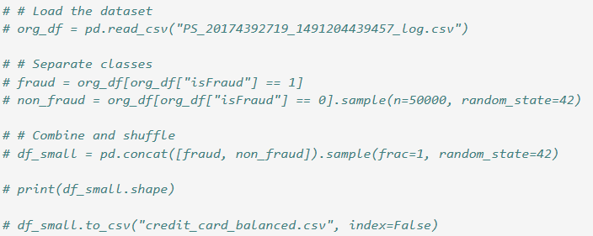
Figure 4.1: Loading the dataset
The original dataset has huge records, which can cause complexity during data analysis. In order to overcome this situation, a new dataset, credit_card_balanced, has been created using the original dataset, where all fraud columns and 50,000 random non-fraud records were included.
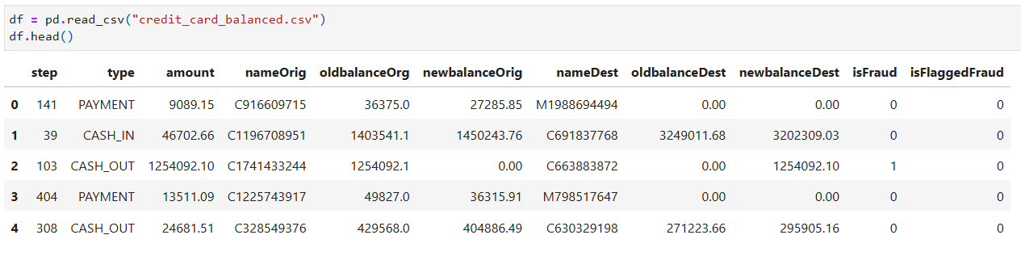
Figure 4.2: Overview of the dataset
The output indicates the first five rows of the credit_card_balanced dataset with all 11 variables.

4.2.2 Dataset Features
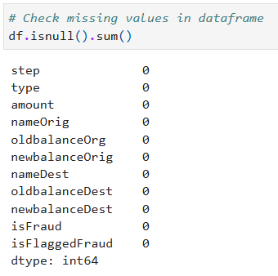
Figure 4.3: Checking missing values
In order to check the null values present in the dataset, the isnull().sum() function has been used. The output indicates that the dataset does not contain any missing values.
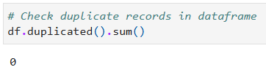
Figure 4.4: Checking duplicate values
The duplicated().sum() function has been used to check the presence of duplicate values in the dataset. The result denotes that it does not include any duplicate values.
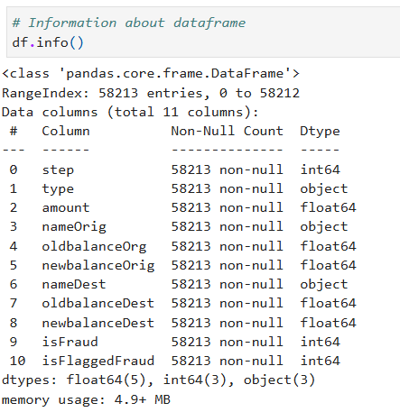
Figure 4.5: Information about the dataset
The info() function was used to check the data types, overall structure and total number of records. The result indicates that the dataset has 5 float-type variables, 3 integer-type variables and 3 object-type variables.

4.2.3 Data Distribution
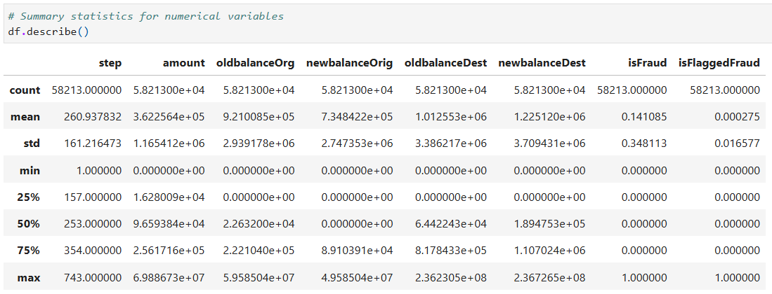
Figure 4.6: Descriptive statistics
In order to understand the distribution, central tendency and variation in transaction amounts and balances, descriptive statistics have been performed. The output highlights that there is a large gap between the 75th percentile and the maximum values on the amount variable. In addition, the balance columns have outliers, which need to be handled before proceeding with further data analysis.

4.2.4 Data Visualisation
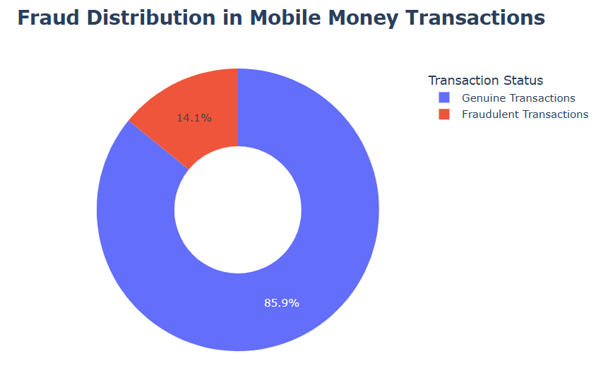
Figure 4.7: Fraud distribution in mobile money transactions
The output of the pie chart indicates that the dataset is highly imbalanced, as only 14.1% of transactions are fraudulent and 85.9% are genuine. Therefore, the data is highly imbalanced for predicting mobile money fraud detection.
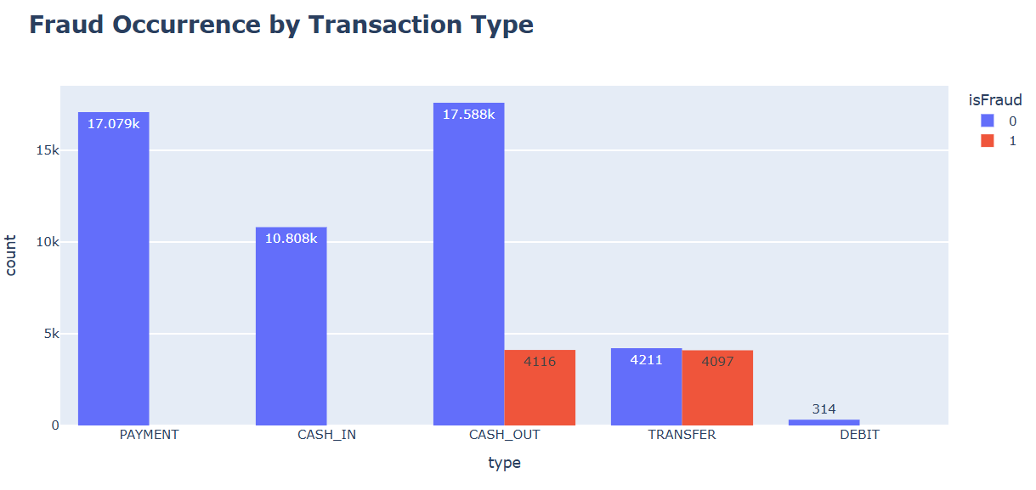
Figure 4.8: Fraud occurrence by transaction type
The output of the bar graph demonstrates that fraudulent activities occur only in CASH_OUT and TRANSFER transaction types. Other transaction types do not contain any type of fraudulent transactions. Therefore, CASH_OUT and TRANSFER transaction types need to be monitored properly to identify the fraud transactions.
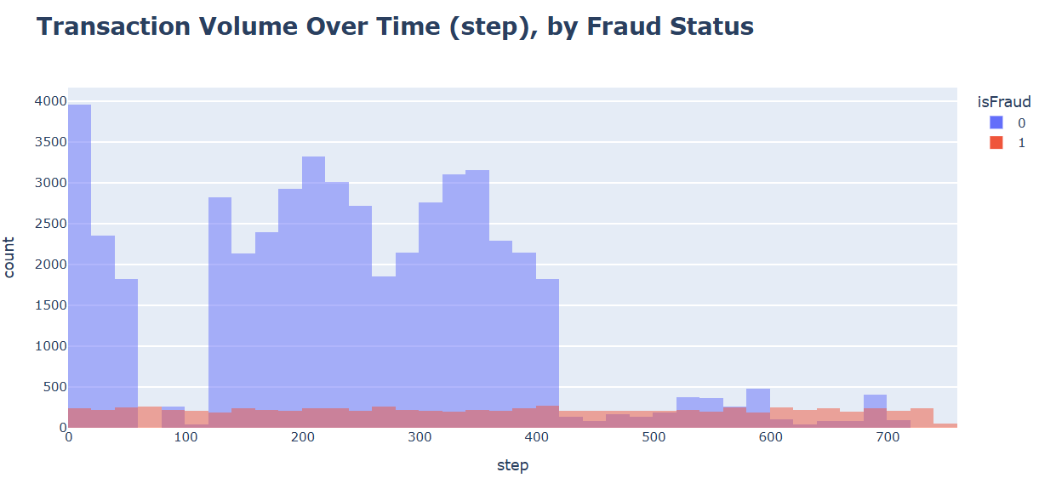
Figure 4.9: Transaction volume over time
The above graph indicates that almost equal transaction amounts were fraud across different times of the day. However, the non-fraudulent transactions varied across different times in day. Therefore, it is complex to identify a particular time when fraudulent transactions can occur.
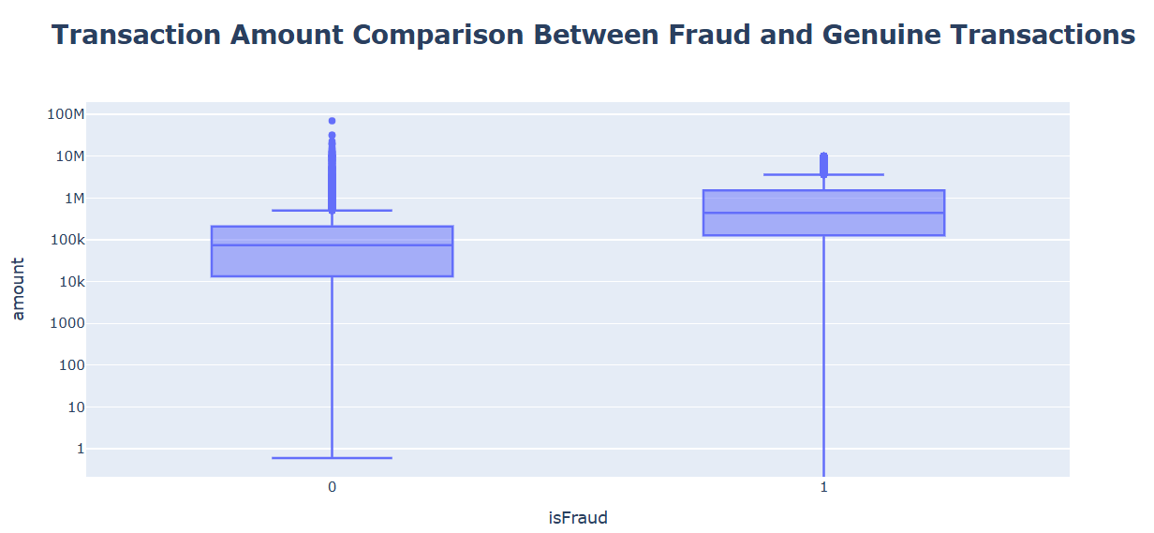
Figure 4.10: Transaction amount comparison between fraud and genuine transactions
The box plot indicates that fraudulent transactions have a higher transaction amount compared to genuine transactions, with a long tail of very large amounts. Since fraudulent transactions include higher amount, this graph is appropriate for depicting the actual scenario.
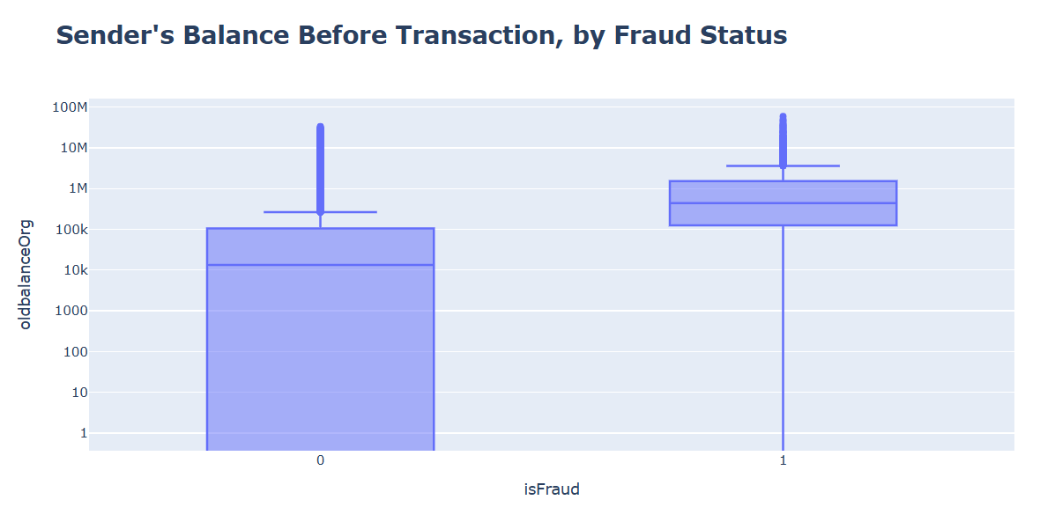
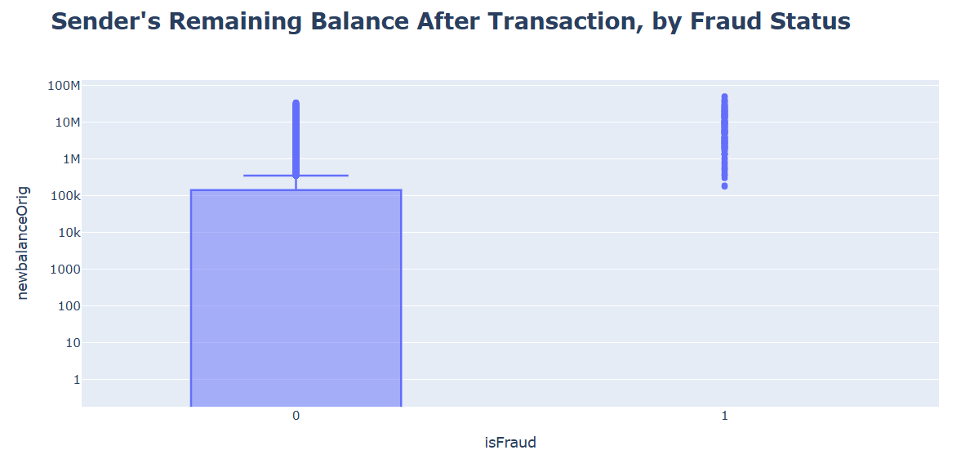
Figure 4.11: Sender’s balance before transaction and after transaction
The sender’s balance was high before fraudulent transactions because hackers tend to target accounts with higher balances. After the fraudulent transaction, the sender’s account balance tended to be almost 0, as hackers emptied the entire account balance.
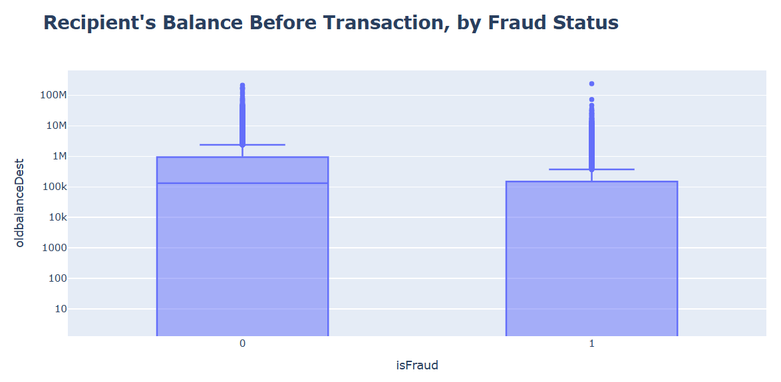
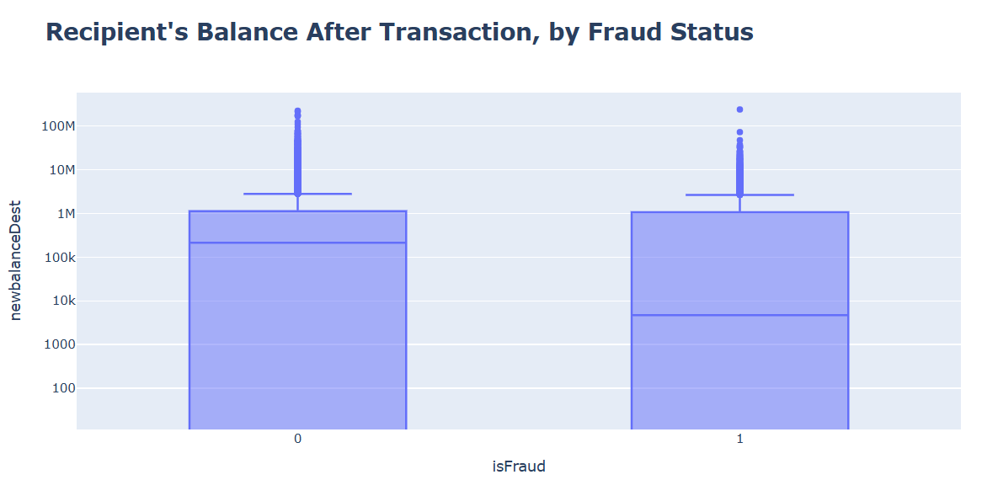
Figure 4.12: Recipient’s balance before transaction and after transaction
The recipient’s balance before the transaction indicates a wide spread for fraudulent and genuine transactions. Similarly, the recipient’s balance increased after transactions from the sender’s account for both fraud and genuine cases.

4.2.5 Correlation Analysis
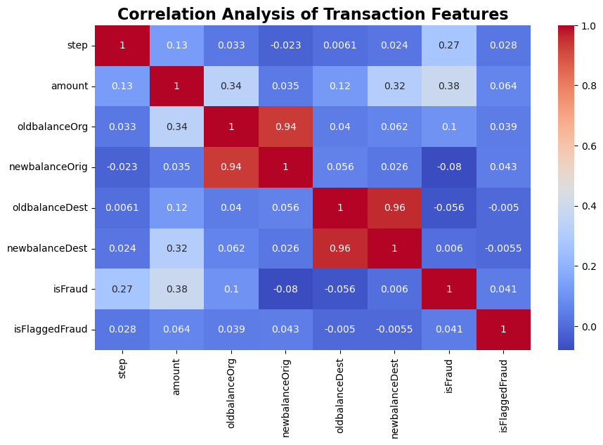
Figure 4.13: Correlation heatmap
The correlation heatmap shows the interrelationship among each variable present in the dataset. The heatmap indicates that the balance-related features have strong relationships with each other. However, the isFraud variable has low-to-moderate and negative relationships with other variables.

4.2.6 Data Preprocessing
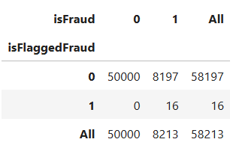
Figure 4.14: Crosstabulation
The crosstabulation has been performed to check the fraud transitions based on large transfers. The output indicates that only a few transactions are fraudulent based on the large transfer amount.
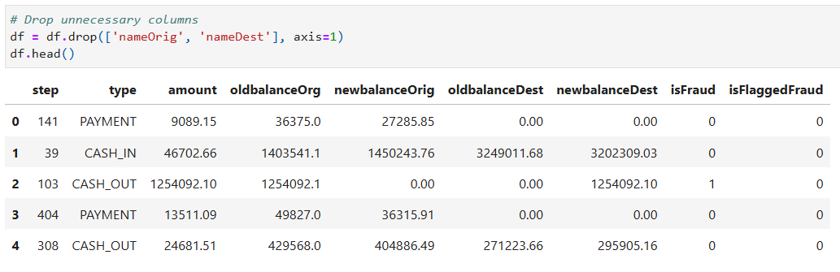
Figure 4.15: Removing nameOrig and nameDest columns
Since the nameOrig and nameDest variables are object type and unique account identifiers, these variables are not useful in predicting mobile money fraud activities. As a result, these variables are removed from the dataset to proceed with further analysis.
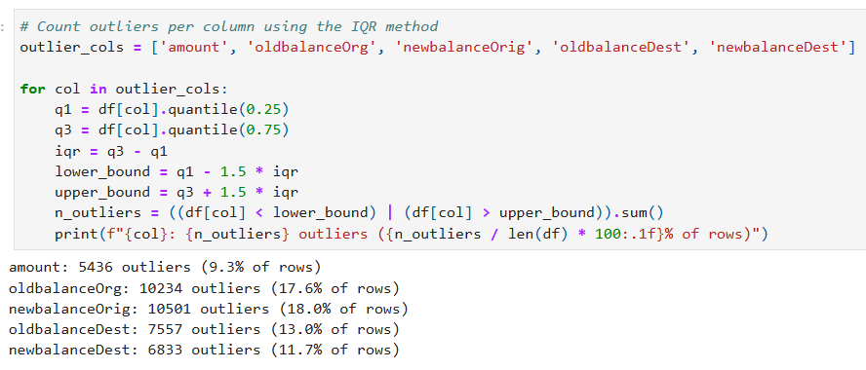
Figure 4.16: Outlier detection
Interquartile Range (IQR) method has been used to count outliers in each skewed numeric column. The output indicates that the amount variable has approximately 9% outliers, whereas the newbalanceOrig variable has 18% outliers. This step is beneficial for identifying the imbalance data so that these can be easily handled through proper methods.
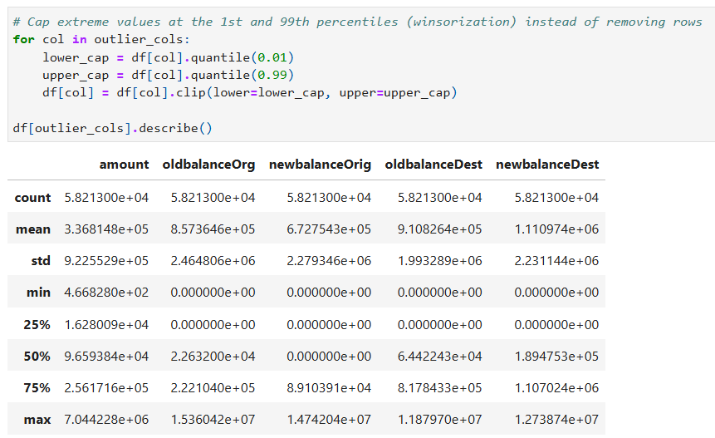
Figure 4.16: Handling outliers
Winsorization method has been applied by capping values at the 1st and 99th percentiles instead of removing rows. This is beneficial for keeping all transactions in the dataset by reducing the impact of extreme values.
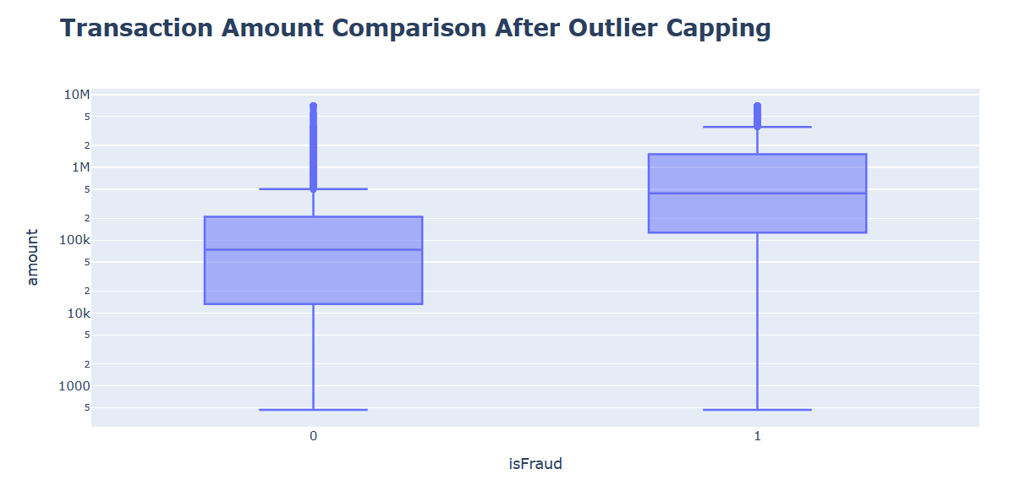
Figure 4.17: Transaction amount comparison after outlier handling
The re-plot of the box graph after outlier capping highlights that the extreme tail has been controlled. As a result, the dataset becomes balanced to predict mobile money fraud detection using machine learning algorithms.
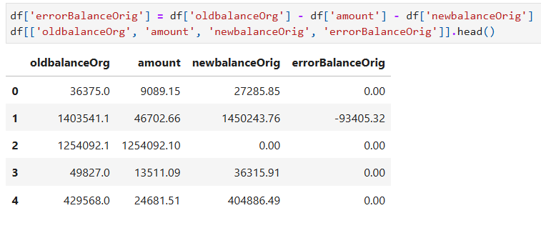
Figure 4.18: Creating errorBalanceOrig variable
A new variable, errorBalanceOrig, has been developed in this stage to ensure that oldbalanceOrg has an equal balance with (amount - newbalanceOrig). A non-zero value indicates a balance inconsistency and indicates a fraudulent transaction.
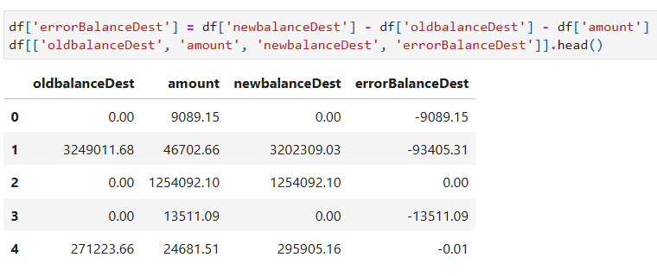
Figure 4.19: Creating errorBalanceDest variable
Another new variable, errorBalanceDest, has been created to ensure whether the recipient’s account increased as the same amount of money deducted from the sender’s account.
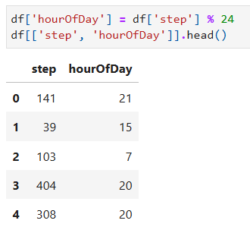
Figure 4.20: Calculating the hour of the day
In order to identify patterns of fraudulent and genuine transactions on a daily basis, the hour of the day has been calculated.
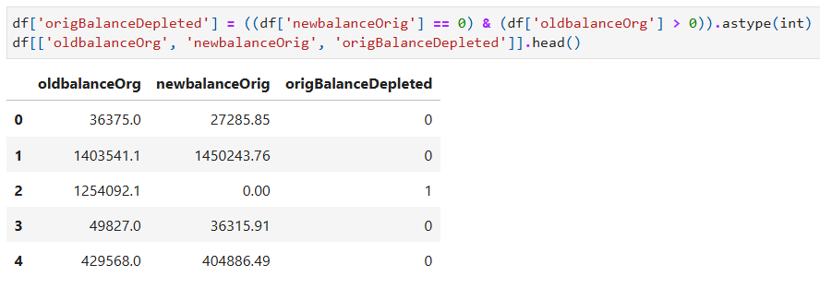
Figure 4.21: Creating origBalanceDepleted feature
The origBalanceDepleted variable has been created to check whether the sender’s account was fully emptied after the transaction in a binary format.
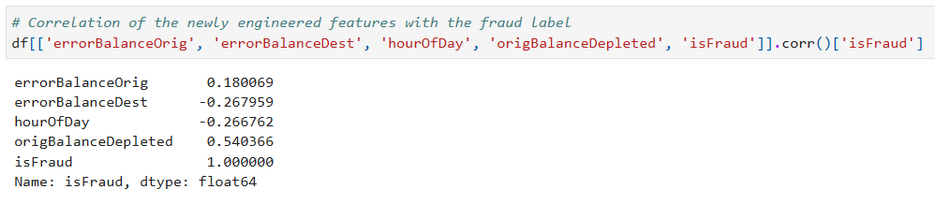
Figure 4.22: Correlation of the new features
The above result indicates the correlation among newly engineered feature variables, where isFraud is moderately correlated only with the origBalanceDepleted variable.
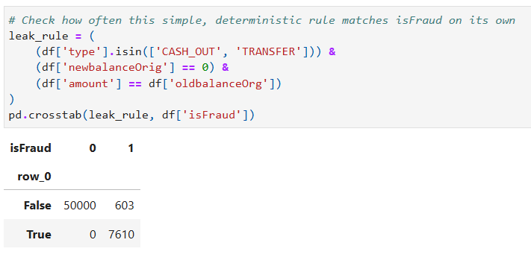
Figure 4.23: Checking data leakage
A rule has been applied to check for any data leakage in the final dataset by including conditions of transaction type CASH_OUT or TRANSFER, and newbalanceOrig = 0 and amount = oldbalanceOrg. The output shows that the rule effectively identified 7,610 fraud cases, which ensures a strong relationship with transaction patterns and fraudulent activity.
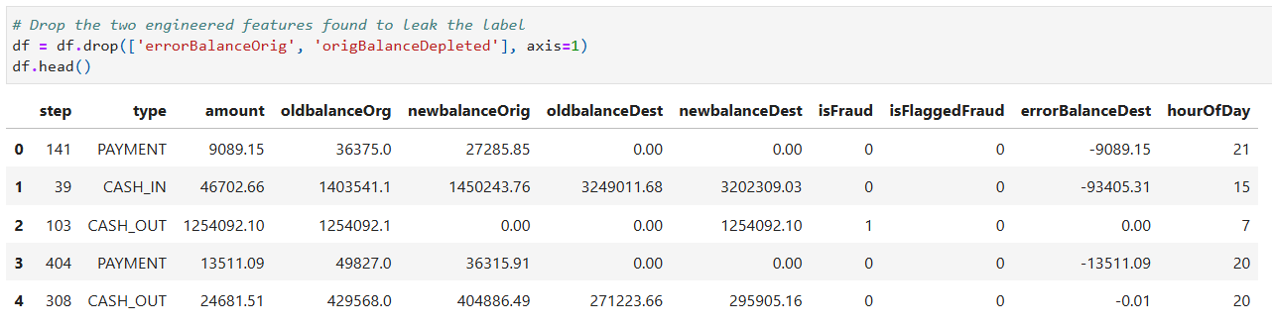
Figure 4.24: Dropping unnecessary columns
The data leakage rule identified that the errorBalanceOrig and origBalanceDepleted variables were directly capturing the rule instead of helping the model to learn real fraud patterns. Therefore, these two variables have been removed from the dataset to avoid data leakage.
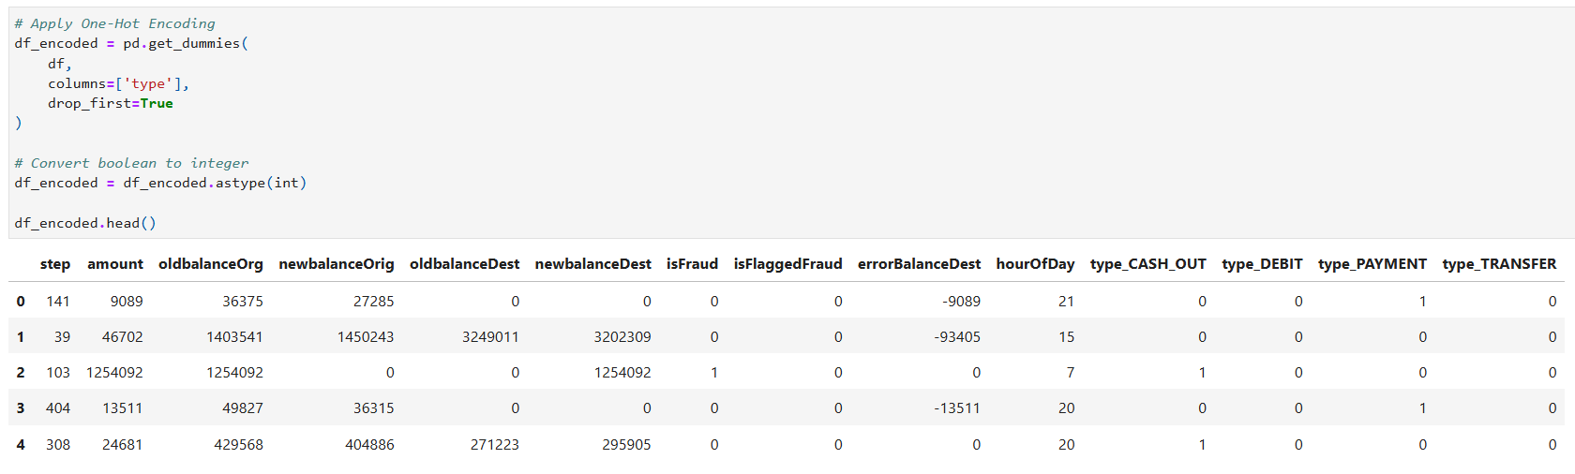
Figure 4.25: Applying one-hot encoding
The one-hot encoding method has been applied to transform the categorical variables into numerical formats.
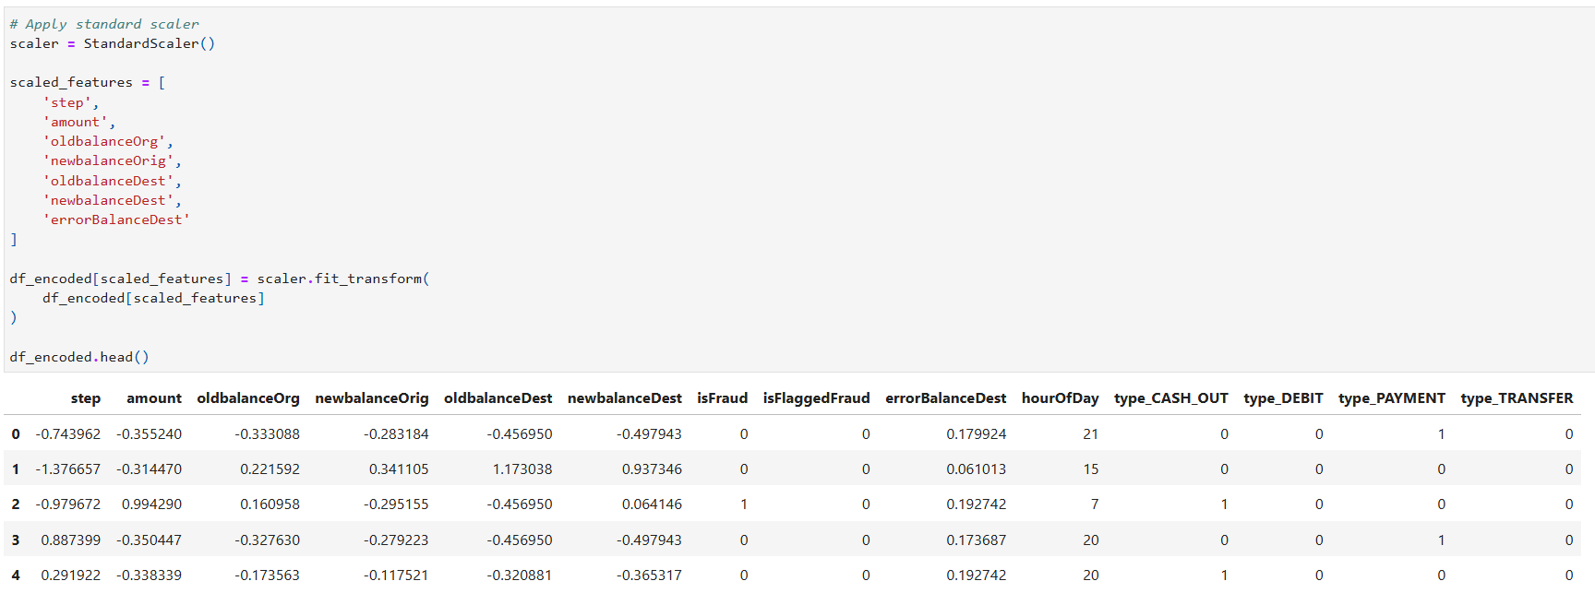
Figure 4.26: Applying standard scaler
The StandardScaler function has been applied to ensure a common scale for all the variables. This would help to improve convergence speed and model performance to get accurate results.
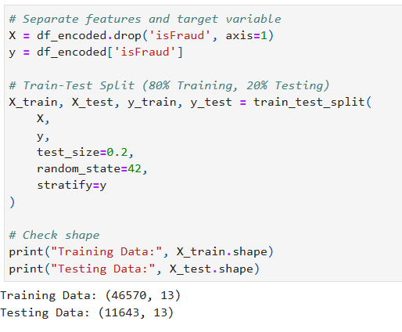
Figure 4.27: Selecting target variable and features and dataset splitting
The isFraud variable has been selected as the target variable, and the others as features to perform mobile money fraud detection. After that, the entire dataset was split into an 80:20 ratio, where 80% of the data would be used for training the model, and 20% would be for testing the model performance.

4.3 Comparative Analysis of ML Models
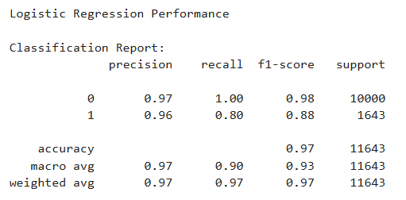
Figure 4.28: Classification report for Logistic Regression
The result indicates that the Logistic Regression model achieved an accuracy of almost 97%, with 88% of F1-score for fraud transactions.
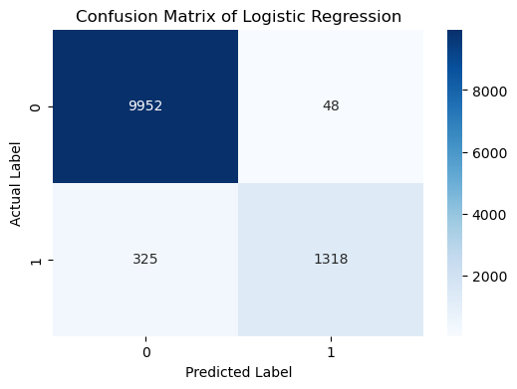
Figure 4.29: Confusion matrix for Logistic Regression
The confusion matrix highlights that the Logistic Regression model classifies 9952 true negatives, 1318 true positives, 48 false positives and 325 false negatives.
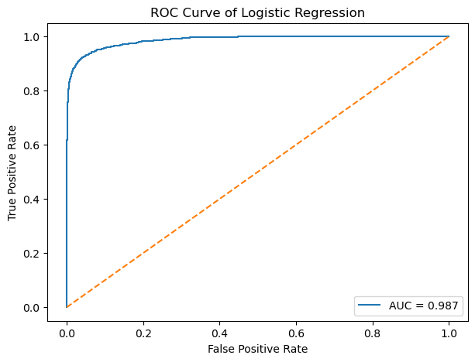
Figure 4.30: ROC curve for Logistic Regression
The ROC curve ensures an excellent classification performance of the Logistic Regression model with an AUC of 0.987, which indicates high sensitivity and low false-positive rates.
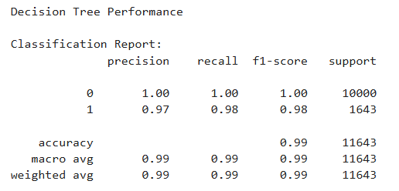
Figure 4.31: Classification report for Decision Tree Classification
The above result indicates that the Decision Tree Classification model achieved an accuracy of almost 99%, with 98% of F1-score for fraud transactions.
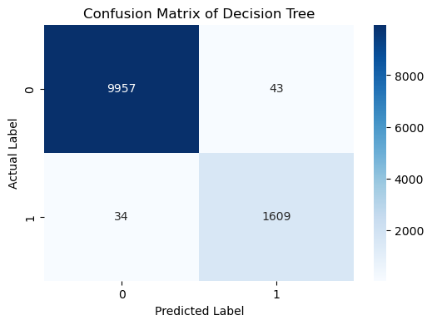
Figure 4.32: Confusion matrix for Decision Tree Classification
The output of the confusion matrix indicates that the Decision Tree Classification model correctly classifies 9957 true negatives, 1609 true positives, 43 false positives and 34 false negatives.
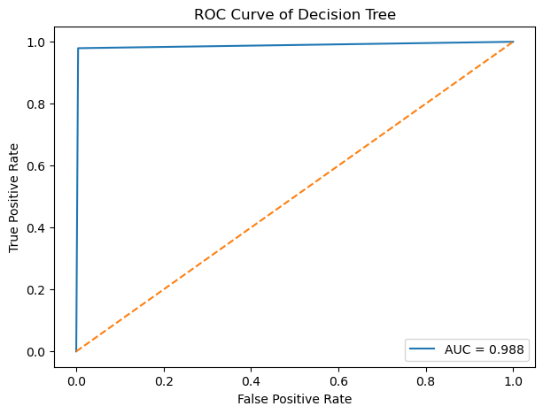
Figure 4.33: ROC curve for Decision Tree Classification
The ROC curve of the Decision Tree Classification model indicates a high AUC score of 0.988, which ensures high accuracy in predicting mobile money fraud detection.
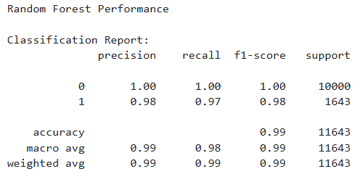
Figure 4.34: Classification report for Random Forest Classification
It is clear from the above results that the Random Forest Classification model achieved an accuracy of almost 99%, with 98% of F1-score for fraud transactions.
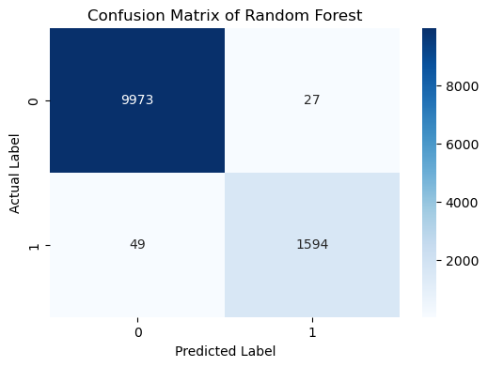
Figure 4.35: Confusion matrix for Random Forest Classification
It is clear from the above output of the confusion matrix that the Random Forest Classification model correctly classifies 9973 true negatives, 1594 true positives, 27 false positives and 49 false negatives.
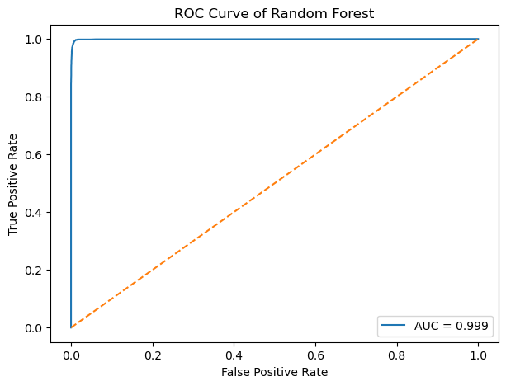
Figure 4.36: ROC curve for Random Forest
The ROC curve of the Random Forest Classification model shows the highest AUC score of 0.999, which indicates the model can predict the most accurate results by lowering false-positive rates.
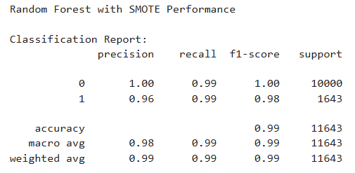
Figure 4.37: Classification report for Random Forest Classification with SMOTE
After applying the SMOTE method to the Random Forest Classification model to balance the classes, the precision score was reduced, and recall was improved for fraud cases.
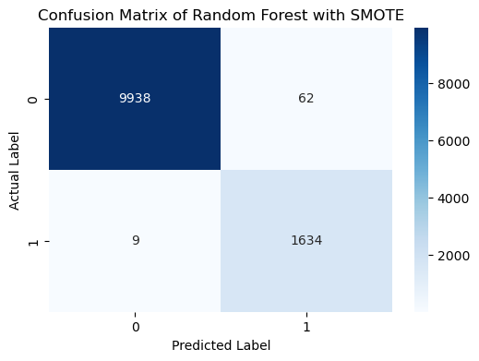
Figure 4.38: Confusion matrix for Random Forest with SMOTE
The Random Forest Classification model with SMOTE method classifies the highest true positives (1634) and the lowest false negatives (9).
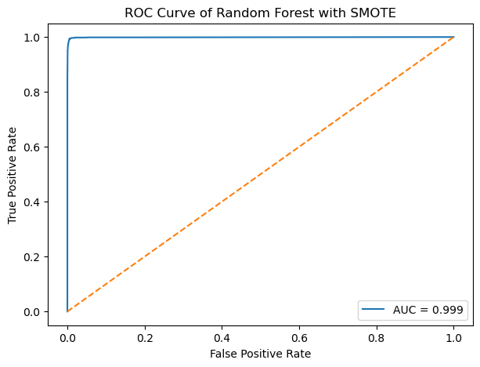
Figure 4.39: ROC curve for Random Forest with SMOTE
The AUC score in the ROC curve of this model was the same as the simple Random Forest Classification model.
After the comparative analysis of all machine learning models, it can be stated that the Random Forest model with SMOTE has achieved the highest accuracy for mobile money fraud detection. This model also achieved highest true positives and lowest false negatives. The precision, recall and F1-score are also highest in this model compared to other machine learning models.
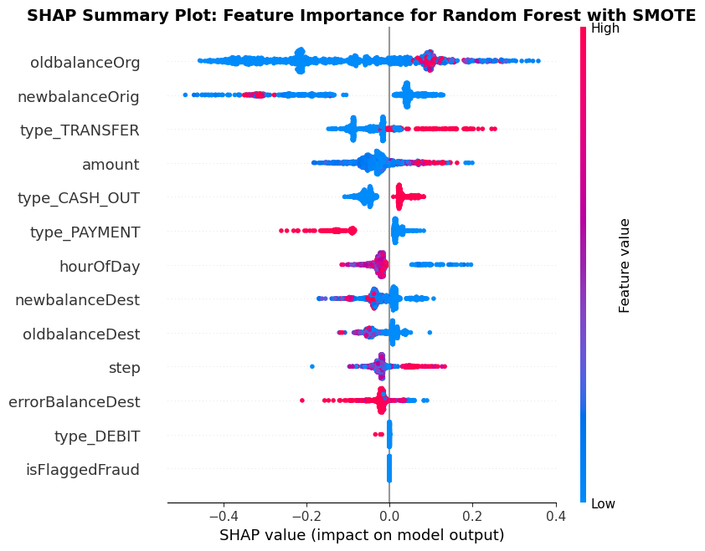
Figure 4.40: SHAP summary plot
The TreeExplainer method in SHAP was applied to explain which features drive fraud predictions using the Random Forest Classification model with SMOTE. It is clear from the above figure that oldbalanceOrg has the highest impact on predicting fraudulent transactions, followed by newbalanceOrig and type_Transfer. However, type_DEBIT and isFlaggedFraud have the minimum influence in predicting mobile money fraud detection.
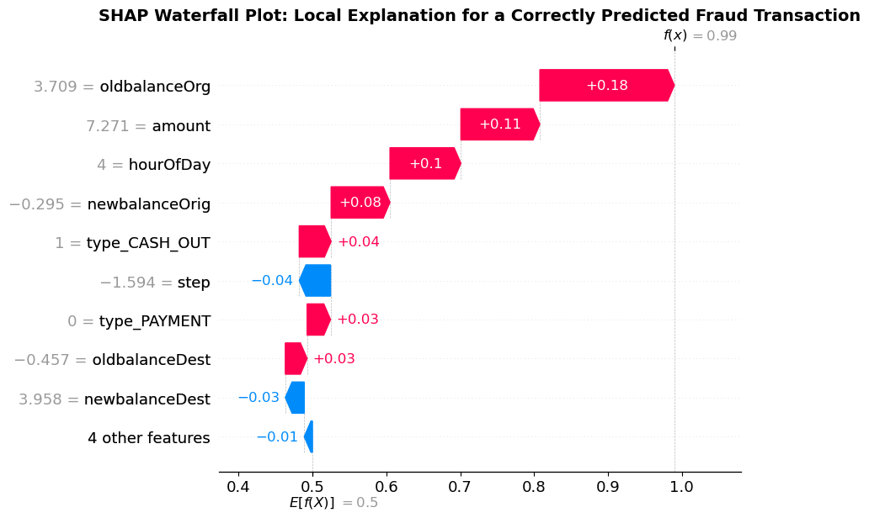
Figure 4.41: SHAP waterfall plot
The waterfall model in SHAP was also applied to identify the contribution of individual features in a single fraud transaction. The output indicates that oldbalanceOrg has the highest positive contribution, followed by amount, hourOfDay and newbalanceOrig. However, step and newbalanceDest have a negative influence on reducing the accuracy of the model prediction.

4.4 Secondary Thematic Analysis

4.4.1 Sources Listing
The source listing is the first stage of thematic analysis where different relevant industrial sources are collected and present their data (Ahmed et al. 2025). The below table provides the information collected from different news and industry reports based on different reasons of mobile money fraud prediction.
Source | Year | Source Type | Key Focus
Reuters; Associated Press | 2024 | News reports | Social engineering, user manipulation and fraud awareness
Banque de France; Outseer | 2022 | Industry reports | Authentication weaknesses and trusted-device vulnerabilities
The Verge; The Guardian | 2024 | News reports | Fraud governance, monitoring and delayed intervention
Sift; NICE Actimize | 2022 | Industry reports | Third-party risks and interconnected payment ecosystems
Table 4.1: Listing qualitative sources

4.4.2 Theme Coding
Theme coding is the second stage of thematic analysis where different themes are developed based on keywords collected from sources listing (Christou, 2022). The below table shows that a total of four themes were developed for this research based on the collected keywords from different sources.
Main Theme | Supporting Sources
Theme 1: Human and Behavioural Vulnerabilities | Reuters (2024); Associated Press (2024)
Theme 2: Technological and Authentication Weaknesses | Banque de France (2022); Outseer (2022)
Theme 3: Fraud Governance and Detection Gaps | The Verge (2024); The Guardian (2024)
Theme 4: Payment Ecosystem and Third-Party Risks | Sift (2022); NICE Actimize (2022)
Table 4.2: Initial coding of themes

4.4.3 Summary Table
Theme | Key Finding | Root Cause
Human and Behavioural | Fraudsters exploit trust and awareness gaps. | User vulnerability
Technological and Authentication | Weak authentication enables security bypasses. | Technology weaknesses
Fraud Governance and Detection | Poor monitoring delays fraud identification. | Governance deficiencies
Payment Ecosystem and Third-Party | Interconnected providers create additional vulnerabilities. | Ecosystem complexity
Table 4.3: Summary table of themes

4.4.4 Theme 1: Human and Behavioural Vulnerabilities
Human and behavioural vulnerabilities are crucial in mobile and digital payment fraudulent activities. According to the report of Reuters (2024), more than 252,000 authorised push-payment scams occurred in the UK in 2023. As a result of these scams, a financial loss was experienced with a value of approximately £341 million. These scams occurred as fraudsters manipulated victims into authorising payments, which indicates the importance of trust and limited fraud awareness. On the other hand, another report by the Associated Press indicated that Zelle users faced widespread fraud in 2024 (Veiga, 2024). According to the report of CFPB, consumers lost more than $870 million because of this fraud, which indicates that inadequate safeguards failed to protect users. However, this case cannot be entirely attributed to consumer behaviour, as platform design and safeguards can also influence behavioural vulnerabilities. From these reports, it can be stated that mobile payment fraud cannot be entirely discussed through technological weaknesses. Human and behavioural factors can create opportunities for fraudsters to manipulate for fraudulent transactions.

4.4.5 Theme 2: Technological and Authentication Weaknesses
Technological and authentication weaknesses are significant factors in the occurrence of mobile payment fraud. According to the report of Banque de France (2022), mobile card payments increased by 137% in 2022, whereas mobile payments remained at a high fraud rate of 0.061% at point-of-sale. This report discussed the e-wallet enrollment processes, which do not always require strong authentication. As a result, it indicates that weakness in the authentication stage can raise the chance of fraud occurring. Similarly, the Outseer Fraud & Payments Report 1H showed that 75% of fraudulent transactions were done in online-banking payment activities from trusted accounts and trusted devices (Outseer, 2022). On the other hand, 70% of fraudulent transactions occurred through mobile channels. These reports criticised the assumption that trusted devices and appropriate authentication can always secure mobile transactions. However, device trust and inadequate authentication can help fradusters to bypass the secure controls for fraudulent activities. Therefore, technological and authentication weaknesses need to be considered alongside human and behavioural factors in occurring mobile payment fraud transactions.

4.4.6 Theme 3: Fraud Governance and Detection Gaps
The weaknesses in fraud governance and detection can increase the possibilities of occuring mobile payment fraud. According to a report by The Verge, the CFPB alleged that Zelle, along with its partner banks, failed to give adequate protection to customers, which caused more than $870 million in financial losses (Roth, 2024). It has been identified that limited identity verification, inadequate fraud controls and insufficient communication increase fraudulent activities in mobile payments. On the other hand, another report by The Guardian indicated that UK banks implemented new rules to delay suspicious payments up to four working days (Partington, 2024). It indicated that existing systems failed to provide sufficient time to investigate suspicious fraud. These reports indicate that human behavours and technological weakneeses are not solely reponsible for mobile payment fraud transactions. Inadequate monitoring, delayed intervention, and insufficient information sharing can also motivate fraudsters to perform fraudulent transactions. However, it has also been identified that strong governance mechanisms can strengthen fraud detection capabilities. Therefore, effective fraud prevention requires strong governance mechanisms and strong systems to detect unusual activities.

4.4.7 Theme 4: Payment Ecosystem and Third-Party Risks
Payment ecosystem and third-party risks also play crucial roles in fraudulent transactions occurring through mobile payments. According to a report by Sift’s Q1 2022 Digital Trust & Safety Index, payment fraud attack rates increased by 70% across fintech, with a 121% growth in fintech transaction volumes in 2021 (SIFT, 2022). This report focuses on the exploitation of vulnerabilities by fraudsters in different merchants and digital services. As a result, it demonstrates that interconnected ecosystems can increase the opportunities for organising mobile payment fraud. Similarly, the report presented by NICE Actimize indicated that fraud transactions exceeded $110 trillion, which increased 41% fraud rate (NICE Actimize, 2022). It has been observed that these frauds occured maximum in third-party billion services through identity theft. Third-party providers and interconnected payment channels can increase vulnerabilities for fraudsters to make fraudulent transactions. Therefore, effective prevention techniques are required to detect mobile money fraud transactions.

4.5 Chapter Summary
This chapter discussed the results of both quantitative analysis and qualitative analysis. From the results of the quantitative analysis, it has been identified that the Random Forest Classification model with SMOTE gives the highest accuracy for mobile money fraud detection. In addition, the results of the thematic analysis indicate that human behaviour, technological weaknesses, weak governance mechanisms, interconnected payment ecosystems and third-party providers are significant factors for occurring mobile money fraud transactions.

Chapter 5: Discussion

5.1 Introduction
The results and discussion chapter focuses on critically discussing the findings obtained from both qualitative and quantitative analyses. The results of quantitative analysis evaluate the patterns of mobile payment fraud transactions through relevant statistical and machine-learning techniques. In addition, the findings from qualitative analysis apply thematic analysis to secondary information to identify the actual root causes of mobile payment fraud. These findings are critically discussed in this chapter with the help of aligning them with the existing literature. This chapter focuses on the integration of both qualitative and quantitative findings to provide an understanding of mobile fraud transaction patterns and the actual reasons for mobile payment fraud.

5.2 Discussion and Interpretation of Results

5.2.1 Interpretation of Results from Machine Learning Algorithms
The quantitative findings identified important patterns in mobile payment fraud detection, which strongly align with the existing literature. For example, the dataset included high class imbalance because fraudulent activities represented only 14.1% of transactions. Hajek et al. (2023) emphasised that imbalanced datasets need appropriate balancing techniques to perform reliable classification. Therefore, it can be stated that the selection of the SMOTE method to handle class imbalance is highly justified for this research.
In addition, the exploratory data analysis identified that fraudulent transactions occurred only through CASH_OUT and TRANSFER transaction types. These findings align with the literature that transaction-type information is beneficial for supporting fraud detection classification. According to Razaq et al. (2021), account takeover is an important account fraud mechanism in mobile payments. Fraudulent transactions also had larger transaction amounts and significant decreases in sender balances. These patterns suggest that the financial transaction characteristics can be used to classify the frauds.
Strong relationships between balance-related variables were identified in the correlation analysis. However, it has also been identified that individual relationships with other variables were low for the isFraud variable. Silva et al. (2021) showed that the representation of features can play a significant role in impacting the performance of a machine learning model. Thus, a correlation cannot be sufficient to describe nonlinear relationships in fraud information. As a result, feature engineering provided additional behaviour and transactional data that can be used for classification.
Comparative results indicate that Decision Tree and Random Forest achieved around 99% accuracy. These findings are supported by the research of Lokanan (2023), which revealed that the Random Forest algorithm performs consistently in fraud detection. However, Sengupta and Das (2023) found that CatBoost performed better in their experiments. It demonstrated variations in performance outcomes depending on the specific dataset and modelling context.
From the comparative results, it has been identified that the Random Forest with SMOTE model provided the best result for Fraud detection. It generated a total of 1,634 correct positive results and only 9 false negatives. The improvement in the result highlights the need to emphasise not only overall accuracy but also the overall classification report, including recall. This aligns with Modell et al. (2025), who have illustrated that the balancing approach can significantly influence the performance of the model. However, an increase in precision suggests a difference between false-positive and fraud detection rates.
Finally, the SHAP analysis identified oldbalanceOrg, newbalanceOrig and type_Transfer as significant predictors. This aligns with Vijayanand and Smrithy (2025), who highlighted the significance of XAI in enhancing the transparency of models. Therefore, the results show that getting accurate results in detecting mobile money fraud requires a compromise between prediction accuracy, minority class detection, interpretability, and data leakage prevention.

5.2.2 Discussion of Theme Analysis
It has been identified from the thematic analysis that there are several reasons for mobile payment fraud occurring. Four themes have been generated by collecting information from newspaper articles and industry reports to identify the root causes of mobile payment fraud. These themes include human vulnerabilities, technological weaknesses, governance gaps and ecosystem risk. These findings from the thematic analysis strongly align with the literature review by identifying multiple causes of fraudulent activities in mobile transactions. For example, Sayibu et al. (2025) identified that fake SMS is one of the primary reasons for mobile payment fraud. Similarly, Razaq et al. (2021) found that account takeover, phishing, fake applications and malware are other crucial factors misguiding people to send money to fraudsters. Therefore, fraud vulnerabilities are not only limited to individual or technical weaknesses but also governance gaps and ecological risks.
The first theme illustrated that human behaviour gives significant opportunities for fraudulent payment operations. Reuters (2024) reported that significant authorised push-payment losses occur due to manipulated payment authorisation. This finding strongly supports the literature of Akesson, Gathergood and Quispe-Torreblanca (2026) on emotional pressure affecting victim payment decisions. However, user behaviour is not the only reason for providing opportunities to fraudsters. As per Behera, Bala and Rana (2023), weak authentication can lead to the disclosure of sensitive information. Therefore, the vulnerability of behaviour and the vulnerabilities of technology and organisation are interdependent in occurring fraudulent transactions through mobile payment.
The second theme identified the importance of technological vulnerabilities and authentication failures for fraudulent transactions. Banque de France (2022) stated that there are high rates of mobile payment adoption and significant exposure to fraud. These findings also identified that there is weak authentication for e-wallet enrolment. In addition, Outseer (2022) also highlighted that trustworthy accounts and devices were used to make fraudulent transactions of large amounts. The results contradict the statement that transaction validity can be guaranteed by device recognition. These findings align with Compagnino et al. (2025), who highlighted interpretability as a key challenge for complex fraud-detection models. Therefore, complementary behavioural and analytical controls are necessary for stronger authentication in mobile payments.
The third theme emphasises the failures in governance, monitoring and intervention on fraud. For example, it has been identified from the case of Zelle that there is a lack of identity verification and fraud protection. These findings strongly align with the literature of Hajek et al. (2023) that illustrated how crucial it is to use the right analytical tools to identify minority fraud instances. However, machine learning is not enough to overcome weaknesses in investigation and response at the organisational level. The evidence from the Guardian (2024) on delayed payments focused on how governance structures provide opportunities for intervention. Therefore, fraud prevention must involve collaboration among detection, investigation, and accountability.
The fourth theme illustrated that integrated payment marketplaces create new vulnerabilities for fraudulent transactions. According to Sift (2022), fintech fraud is also rising, and transaction volumes are growing significantly. In addition, NICE Actimize (2022) highlighted risks involving third-party billing services and identity-related fraud. The results are consistent with the literature reviews that fraud can occur within the connected channel. Thus, mobile payment security should not only be about a particular application or a particular user. Therefore, thematic findings revealed how mobile payment fraud occurs through inter-relating vulnerabilities through behavioural, technological, governance and ecosystem measures.

5.3 Chapter Summary
This chapter focused on presenting a critical discussion of both quantitative and qualitative findings related to mobile payment fraud. These findings were supported by existing literature to ensure the acceptability of these research outcomes. Therefore, it can be stated from the above discussion that effective fraud prevention requires not only technical but also organisational controls.

Chapter 6: Conclusion and Recommendation

6.1 Conclusion
The research examined the techniques to prevent mobile payment fraud transactions through machine learning algorithms and identified root causes of fraudulent activities. The findings revealed that mobile payment fraud is a multidimensional problem, which occurs due to human behaviour, technological weaknesses, governance gaps and third-party ecosystem risks. In addition, inadequate authentication, weak monitoring and interconnected payment channels include significant vulnerabilities for fraudulent transactions through mobile payment.
On the other hand, the results from the quantitative analysis demonstrated that machine learning models are effective in identifying fraudulent transactions. Random Forest with SMOTE model is the most significant model, which provides the highest accuracy and recall of 99% and the lowest false negatives in money payment fraud detection. In addition, the SHAP technique also helps in identifying the important predictors such as balance-related and transaction-type features for fraud detection. Therefore, it can be concluded that effective mobile payment fraud prevention requires the integration of accurate machine learning models with explainable AI, stronger authentication, effective governance and continuous monitoring.

6.2 Linking with Aim and Research Questions
Aim
The research aim was fulfilled by the results of machine learning algorithms for mobile payment fraud detection. Four machine learning models, Logistic Regression, Decision Tree, Random Forest and Random Forest with SMOTE, were assessed through accuracy, recall, precision, F1-score, confusion matrices, and ROC-AUC curve. The findings revealed that Random Forest with SMOTE is the best model, with the highest accuracy and recall of 99% and the lowest false negatives. In addition, SHAP analysis fulfilled the explainable model by identifying the most influential features and their contributions in fraud predictions.
Research Question 1: How efficiently can a Machine Learning-based fraud detection model contribute to improving fraud detection and enhancing the mobile payment service?
The first research question was addressed by the results of quantitative analysis that machine learning models effectively classify fraudulent and genuine transactions. The classification reports help to perform a comparative analysis of four models to select the best machine learning model without depending only on accuracy. The results also highlighted that SMOTE helps in improving the identification of fraudulent transactions by addressing class imbalance. Therefore, the research is successful in providing results through an explainable AI model to strengthen mobile payment fraud detection.
Research Questions 2: What are the ultimate root causes of mobile payment fraud?
The second research question was fulfilled by the results of thematic analysis through industry reports and news articles. It has been identified from the thematic analysis that the four root causes of fraudulent transactions are human and behavioural vulnerabilities, technological and authentication weaknesses, fraud governance and detection gaps, and payment ecosystem and third-party risks. These findings are beneficial for establishing a strong theoretical foundation with the help of demonstrating that mobile payment fraud occurs due to organisational, technological, behavioural, and ecosystem-level vulnerabilities.

6.3 Research Limitation
Area | Limitations Identified
Dataset | A balanced subset of 50,000 randomly selected non-fraud records with all fraud records was used for the analysis. This may reduce the representativeness of real-world transaction patterns.
Class Imbalance | SMOTE enhanced fraud recall and lowered the false negative rate, and resulted in a precision compromise. Thus, model performance does not guarantee to be consistent across different fraud distributions.
Feature Scope | Account identifiers were removed due to their unrepeatability, which may have resulted in the removal of behavioural patterns that were connected to a specific account or to transaction relationships.
Model Generalisability | Direct experience feedback was not collected from consumers, banks, merchants, or fraud investigators. The root causes were identified by examining secondary information and sources.
Secondary Sources | Root causes were identified from secondary sources, limiting direct understanding of experiences from consumers, banks, merchants, and fraud investigators.
Contextual Variation | Findings are based on the context of the organisation and regulation, and therefore some identified causes of the findings may not be applicable to payment ecosystems in all countries.
Table 6.1: Research limitations
(Source: Self-developed)

6.4 Future Scope of Work
Recommendation 1: Implement Explainable Machine-Learning Fraud Detection
Payment providers should use Random Forest combined with some suitable class-imbalance techniques, supported by SHAP-based explainability. The results showed that using Random Forest with SMOTE enhanced fraud recall and minimised false negatives. In addition, SHAP highlighted important features like transaction value and balance-related metrics. For example, Mastercard's Decision Intelligence is an application of AI to decision-making at a transaction-level, which shows how AI can help with payment fraud prevention (Rahmani, 2025). Therefore, organisations should integrate predictive performance with explanations that enable fraud analysts to interpret suspicious transactions.
Recommendation 2: Strengthen Authentication and Real-Time Intervention
Payment providers need to expand their authentication controls as well as real-time transaction monitoring. The recognised vulnerabilities were weak authentication, exploitation of trusted devices, social engineering, and account compromise. For high-risk transactions, multi-factor authentication, behavioural verification, and temporary payment holds should be introduced. The UK banking sector is one example, as banks were allowed to hold suspicious payments for up to 72 hours to provide more time to investigate (Treasury and Siddiq MP, 2024). This shows an example in which technological detection is complemented by operational intervention.

Recommendation 3: Establish Ecosystem-Wide Fraud Governance
There is a need to strengthen cooperation among banks, payment platforms, merchants, regulators and third parties. Qualitative results indicated that fraud may occur through interrelated payment pathways, which leads to a requirement for multiple and continuous approaches to control. Therefore, sharing of intelligence, standardised reporting, coordinated identity verification and third-party risk assessments should become part of effective governance. For example, the Confirmation of Payee initiative allows British payment providers to verify the contents of an account name and stop transactions from being made if they do not match the payment details (Van Praag, 2024). The result of these coordinated controls could limit the risk of fraudulent activities through mobile payments and enhance fraud prevention throughout the payment ecosystem.

6.5 Critical Review and Reflection
My research time was divided between planning the research, reviewing existing literature, methodology, analysis, and writing. Initially, I spent some time gaining insight into the underlying fraud involved in mobile payments and what research gaps may exist in this area. After that, I formulated research questions that were related to machine learning and qualitative research objectives. The literature review took a long time because the report was different from past studies. Next, I processed the data, perform some exploratory analysis, trained models and evaluated performance. Lastly, I did thematic analysis and combined the results with the methodological findings. The below timeline indicates the distribution of all the activities throughout the thesis period.
Research Activity | Week 1-2 | Week 3-4 | Week 5-6 | Week 7-8 | Week 9-10 | Week 11-12
Background context
Research questions development
Literature search and review
Research methodology development
Secondary qualitative and quantitative data collection
Dataset preparation and cleaning
Exploratory data analysis
Machine-learning model development
Model evaluation and comparison
SMOTE and model optimisation
SHAP explainability analysis
Qualitative thematic analysis
Integration of quantitative and qualitative findings
Discussion and recommendations
Final submission
Table 6.1: Timeline
Throughout the research process, there were several challenges I faced, especially in the preparation of the research data and the evaluation of models. Class imbalance included a challenge that needed additional experimentation to enhance fraud detection performance. I also had to recognise and eliminate potentially problematic features that could lead to data leakage. The literature reviews also faced difficulty when trying to interpret the findings that were contradictory across various machine-learning studies. In addition, the methodological challenges of interpreting quantitative results with qualitative themes required additional attention to combine different findings.
I employed a different methodology, using predictive analysis along with qualitative thematic analysis in this research. Instead of focusing solely on the best algorithm, I looked into why fraud is happening at different levels in an organisation. Furthermore, I applied the SHAP analysis to make machine-learning predictions easier to understand. In the analysis, I reflected on the decisions of pre-processing rather than taking the preliminary results as given. It helped me recognise that strong predictive performance does not necessarily ensure practical fraud prevention. The overall impact that I got from the research project helped me to improve my analytical, methodological and critical thinking skills.

References
Abdirahman, A.A., Hashi, A.O., Dahir, U.M., Elmi, M.A. and Rodriguez, O.E.R., 2024. Enhancing security in mobile wallet payments: machine learning-based fraud detection across prominent wallet platforms. International Journal of Electronics and Communication Engineering, 11(3), pp.96-105. https://www.academia.edu/download/117477072/IJECE-V11I3P110.pdf
Acharya, R., (2025). Examining interpretivism in social science research: Exploring subjectivity, context, and meaning in social inquiry. Education Science & Technology. https://journal.skultech.com/index.php/est/article/view/8/11
Ahmed, S.K., Mohammed, R.A., Nashwan, A.J., Ibrahim, R.H., Abdalla, A.Q., Ameen, B.M.M. and Khdhir, R.M., (2025). Using thematic analysis in qualitative research. Journal of medicine, surgery, and public health, 6, p.100198. https://www.sciencedirect.com/science/article/pii/S2949916X25000222
Akesson, J., Gathergood, J. and Quispe-Torreblanca, E., 2026. Preventing payments fraud in the fintech era: new evidence from a behavioural experiment. Available at SSRN 4532757. https://papers.ssrn.com/sol3/Delivery.cfm?abstractid=4532757
Appani, C., 2025. AI-powered threat detection in real-time payment systems. International Journal of Environmental Sciences, 11(19s), p.2025. https://www.academia.edu/download/132155183/IJES_V11_19s_2025_4.pdf
Banque de France. (2022). Observatory of the security of payment means: Annual report 2022 | banque de France. [online] Banque de France. Available at: https://www.banque-france.fr/en/publications-and-statistics/publications/observatory-security-payment-means-annual-report-2022 [Accessed 25 Aug. 2026].
Behera, R.K., Bala, P.K. and Rana, N.P., 2023. Assessing factors influencing consumers' non-adoption intention: exploring the dark sides of mobile payment. Information Technology & People, 36(7), pp.2941-2976. https://www.researchgate.net/profile/Rajat-Behera/publication/365839652_Assessing_factors_influencing_consumers'_non-adoption_intention_exploring_the_dark_sides_of_mobile_payment/links/638d8e75ca2e4b239c8d389c/Assessing-factors-influencing-consumers-non-adoption-intention-exploring-the-dark-sides-of-mobile-payment.pdf
Benites, H.F.B., Rosales, J.L.M., Montalvan, D., Alburqueque, M.P.M.L., Linares, V.L.A., Luz, M., Peña, M., Muro, E.S.P., Flores, A.G., Colonia, C.U. and Cáceres, Y.S., (2025). Research Methodology Applied to the Exact Sciences: Cause and Effec. Editorial Mar Caribe—EMC, Colonia del Sacramento, Uruguay. https://editorialmarcaribe.es/ark:/10951/isbn.9789915698069/ebook.pdf
BioCatch, 2026. Banking scams up 65% globally in last year. Available at: https://www.biocatch.com/press-release/banking-scams-up-65-globally-in-last-year (Accessed on: 27/06/2026).
Cabot, J.H. and Ross, E.G., (2023). Evaluating prediction model performance. Surgery, 174(3), pp.723-726. https://www.sciencedirect.com/science/article/am/pii/S0039606023003185
Carter, J.M., Thompson, E.R., Hughes, M.A., Bennett, S.L. and James, C., 2024. Comparative Study of XAI Techniques in Financial Fraud Detection Systems. https://www.researchgate.net/profile/Charles-James-16/publication/394890811_Comparative_Study_of_XAI_Techniques_in_Financial_Fraud_Detection_Systems/links/68ab7f1fca495d76982fbca7/Comparative-Study-of-XAI-Techniques-in-Financial-Fraud-Detection-Systems.pdf
Cheong, H.I., Lyons, A., Houghton, R. and Majumdar, A., (2023). Secondary qualitative research methodology using online data within the context of social sciences. International Journal of Qualitative Methods, 22, p.16094069231180160. https://journals.sagepub.com/doi/pdf/10.1177/16094069231180160
Christou, P.A., (2022). How to use thematic analysis in qualitative research. Journal of Qualitative Research in Tourism, 3(2), pp.79-95. https://www.researchgate.net/profile/Prokopis-A-Christou/publication/369146265_How_to_use_thematic_analysis_in_qualitative_research/links/646cb5aad0ad0d1094d58c0a/How-to-use-thematic-analysis-in-qualitative-research.pdf
Compagnino, A.A., Maruccia, Y., Cavuoti, S., Riccio, G., Tutone, A., Crupi, R. and Pagliaro, A., 2025. An introduction to machine learning methods for fraud detection. Applied Sciences, 15(21), p.11787. https://www.mdpi.com/2076-3417/15/21/11787
Ding, H., (2023). Qualitative comparative analysis: search target, reflection on the top-down approach, and introduction of the bottom-up approach. International Journal of Qualitative Methods, 22, p.16094069231182634. https://journals.sagepub.com/doi/pdf/10.1177/16094069231182634
Ekbote, N., Dhanshetti, P. and Sakhrekar, S., 2023. Techniques of exploratory data analysis. Madhya Pradesh Journal of Social Sciences, 28(2), pp.5-12. https://www.researchgate.net/profile/Prapti-Dhanshetti/publication/374674185_Techniques_of_Exploratory_Data_Analysis/links/6528e3141a05311a23fbb80c/Techniques-of-Exploratory-Data-Analysis.pdf
Elad, B. and Burnett, S. 2026. Digital Payment Fraud Statistics 2026: Alarming Trends Now. Available at: https://coinlaw.io/digital-payment-fraud-statistics/ (Accessed on: 15/07/2026).
Esna-Ashari, M., (2025). Beyond the black box: A review of quantitative metrics for neural network interpretability and their practical implications. International journal of sustainable applied science and engineering, 2(1), pp.1-24. https://bgsiran.ir/journal/ojs-3.1.1-4/index.php/IJSASE/article/download/133/116
Hairani, H., Widiyaningtyas, T. and Prasetya, D.D., (2024). Addressing class imbalance of health data: a systematic literature review on modified synthetic minority oversampling technique (SMOTE) strategies. JOIV: International Journal on Informatics Visualization, 8(3), pp.1310-1318. https://joiv.org/index.php/joiv/article/download/2283/1037
Hajek, P., Abedin, M.Z. and Sivarajah, U., 2023. Fraud detection in mobile payment systems using an XGBoost-based framework. Information Systems Frontiers, 25(5), pp.1985-2003. https://pmc.ncbi.nlm.nih.gov/articles/PMC9560719/pdf/10796_2022_Article_10346.pdf
Hall, J. and Mansfield, L., (2025). The benefits and complexities of integrating mixed method findings using the Pillar Integration Process: A workplace health intervention case study. Journal of Mixed Methods Research, 19(1), pp.20-40. https://journals.sagepub.com/doi/pdf/10.1177/15586898231196287
Hapase, D.S. and Patil, L.V., 2024. Telecommunication fraud resilient framework for efficient and accurate detection of SMS phishing using artificial intelligence techniques. Multimedia Tools and Applications, 83(41), pp.89111-89133.
Hollmann, N., Müller, S., Purucker, L., Krishnakumar, A., Körfer, M., Hoo, S.B., Schirrmeister, R.T. and Hutter, F., (2025). Accurate predictions on small data with a tabular foundation model. Nature, 637(8045), pp.319-326. https://www.nature.com/articles/s41586-024-08328-6.pdf
Hussain, I. and Asif, M., 2020. Detection of Anomalous Transactions in Mobile Payment Systems. International Journal of Data Analytics (IJDA), 1(2), pp.58-66. https://www.researchgate.net/profile/Muhammad-Asif-66/publication/343146762_Detection_of_Anomalous_Transactions_in_Mobile_Payment_Systems/links/5f1c7dd0a6fdcc9626b37aad/Detection-of-Anomalous-Transactions-in-Mobile-Payment-Systems.pdf
Kambhampati, S.B., Menon, J. and Maini, L., 2023. Ethics in research and publications. Indian Journal of Orthopaedics, 57(11), pp.1722-1734. https://pmc.ncbi.nlm.nih.gov/articles/PMC10593663/pdf/43465_2023_Article_971.pdf
Klimonová, D., Anderková, V., Babič, F. and Majnaric, L.T., (2022). Decision support system improving the interpretability of generated tree-based models. Acta Electrotechnica et Informatica, 22(2), pp.27-33. https://reference-global.com/download/article/10.2478/aei-2022-0009.pdf
Lokanan, M.E., 2023. Predicting mobile money transaction fraud using machine learning algorithms. Applied AI Letters, 4(2), p.e85. https://onlinelibrary.wiley.com/doi/pdf/10.1002/ail2.85
Lopez-Rojas, E. 2017. Synthetic financial datasets for fraud detection. [online] www.kaggle.com. Available at: https://www.kaggle.com/datasets/ealaxi/paysim1/data [Accessed 23 Aug. 2026].
Mill, E.R., Garn, W., Ryman-Tubb, N.F. and Turner, C., 2023. Opportunities in real time fraud detection: an explainable artificial intelligence (XAI) research agenda. International Journal of Advanced Computer Science and Applications, 14(5), pp.1172-1186. https://openresearch.surrey.ac.uk/esploro/fulltext/journalArticle/Opportunities-in-Real-Time-Fraud-Detection/99768966602346?repId=12184120980002346&mId=13184120970002346&institution=44SUR_INST
Muoghalu, A.I., Okonkwo, J.J. and Ananwude, A., 2018. Effect of electronic banking related fraud on deposit money banks financial performance in Nigeria. Discovery, 54(276), pp.496-503. https://papers.ssrn.com/sol3/Delivery.cfm?abstractid=3305555
NICE Actimize. (2022). NICE actimize releases 2022 fraud insights report identifying threat patterns emerging across financial institutions - NICE actimize. [online] Niceactimize.com. Available at: https://www.niceactimize.com/press-releases/nice-actimize-releases-2022-fraud-insights-report-identifying-threat-patterns-emerging-across-financial-institutions-393 [Accessed 25 Aug. 2026].
Outseer. (2022). OutseerTM releases latest fraud & payments report showing authorized push payment (APP) fraud is rife. [online] Outseer.com. Available at: https://www.outseer.com/press-release/report-1h2022 [Accessed 25 Aug. 2026].
Partington, R. (2024). UK banks given extra three days to delay payments in effort to beat scams. [online] the Guardian. Available at: https://www.theguardian.com/money/2024/oct/03/uk-banks-given-extra-three-days-to-delay-payments-in-effort-to-beat-scams [Accessed 25 Aug. 2026].
PWC, 2022. Combating fraud in the era of digital payments. Available at: https://www.pwc.in/assets/pdfs/consulting/financial-services/fintech/payments-transformation/combating-fraud-in-the-era-of-digital-payments.pdf (Accessed on: 27/06/2026).
Rahmani, S., (2025). AI’s Dual-Use Paradox in Financial Fraud: Navigating Offense and Defense in the Digital Era. Sociedad & Tecnología, 8(4), pp.673-692. https://institutojubones.edu.ec/ojs/index.php/societec/article/download/666/1114
Razaq, L., Ahmad, T., Ibtasam, S., Ramzan, U. and Mare, S., 2021. " We Even Borrowed Money From Our Neighbor" Understanding Mobile-based Frauds Through Victims' Experiences. Proceedings of the ACM on human-computer interaction, 5(CSCW1), pp.1-30. https://dl.acm.org/doi/pdf/10.1145/3449115
Reuters. (2024). UK regulator says push payment scams worth 341 mln pounds reported in 2023. Reuters. [online] 1 Aug. Available at: https://www.reuters.com/world/uk/britain-regulator-says-payment-scams-totalling-341-mln-pounds-reported-2023-2024-08-01/ [Accessed 25 Aug. 2026].
Roth, E. (2024). Three of the biggest US banks are facing a lawsuit for ‘widespread fraud’ on Zelle. [online] The Verge. Available at: https://www.theverge.com/2024/12/20/24325923/cfpb-zelle-lawsuit-widespread-fraud [Accessed 25 Aug. 2026].
Salim, A.M., 2022. Assessment of mobile money transaction frauds and consequences confronting zanzibar telecom service providers. Asian Journal of Economics, Business and Accounting, 22(20), pp.16-31. https://www.researchgate.net/profile/Adilu-Salim-2/publication/362000615_Assessment_of_Mobile_Money_Transaction_Frauds_and_Consequences_Confronting_Zanzibar_Telecom_Service_Providers/links/62d51ef066bd1654d66ee909/Assessment-of-Mobile-Money-Transaction-Frauds-and-Consequences-Confronting-Zanzibar-Telecom-Service-Providers.pdf
Salman, H.A., Kalakech, A. and Steiti, A., (2024). Random forest algorithm overview. Babylonian Journal of Machine Learning, 2024, pp.69-79. https://journals.mesopotamian.press/index.php/BJML/article/download/417/289
Sariat, A.F., Siddique, I.J., Hossain, M., Islam, M.M. and Rahman, T., 2025, February. AI Driven Fraud Detection in Financial Ecosystems: A Hybrid Machine Learning Framework. In 2025 International Conference on Electrical, Computer and Communication Engineering (ECCE) (pp. 1-8). IEEE.
Sayibu, U., Asante, M., Abdul-Salam, G. and Frimpong, T., 2025. Fraud Prediction and Prevention in Mobile Money Payment Systems (MMPS): A Systematic Literature Review of Text‐Based Detection Methods. Security and Communication Networks, 2025(1), p.8913715. https://onlinelibrary.wiley.com/doi/pdf/10.1155/sec/8913715
Sengupta, K. and Das, P.K., 2023. Detection of financial fraud: Comparisons of some tree-based machine learning approaches. Journal of Data, Information and Management, 5(1), pp.23-37.
SIFT. (2022). Outsmarting payment fraud in the age of automation. [online] sift.com. Available at: https://sift.com/wp-content/uploads/2025/03/2022_Q1_Digital_Trust_Safety_Index-1.pdf?utm_source=chatgpt.com [Accessed 25 Aug. 2026].
Silva, J.C.S., Macêdo, D., Zanchettin, C., Oliveira, A.L. and de Almeida Filho, A.T., 2021, July. Multi-class mobile money service financial fraud detection by integrating supervised learning with adversarial autoencoders. In 2021 International Joint Conference on Neural Networks (IJCNN) (pp. 1-7). IEEE.
Thar, K.W. and Wai, T.T., 2025, October. An Advanced Hybrid Strategy for Detecting Fraud in Mobile Money Services. In TENCON 2025-2025 IEEE Region 10 Conference (TENCON) (pp. 1919-1923). IEEE.
Treasury, H. and Siddiq MP, T. (2024). New powers for banks to combat fraudsters. [online] GOV.UK. Available at: https://www.gov.uk/government/news/new-powers-for-banks-to-combat-fraudsters [Accessed 8 Sept. 2026].
Van Praag, E., (2024). The future of European payments: Faster, cheaper, more digital and more European; with no one left behind. Journal of Payments Strategy & Systems, 18(4), pp.327-341. https://www.researchgate.net/profile/Emanuel-Van-Praag/publication/388466334_The_future_of_European_payments_Faster_cheaper_more_digital_and_more_European_with_no_one_left_behind/links/67c87e39cc055043ce6decce/The-future-of-European-payments-Faster-cheaper-more-digital-and-more-European-with-no-one-left-behind.pdf
Veiga, A. (2024). Federal regulator sues JPMorgan, Wells Fargo and BofA over Zelle fraud. [online] AP News. Available at: https://apnews.com/article/6cb33c517f7ffc8144e6ec0b31fa1a92 [Accessed 25 Aug. 2026].
Vijayanand, D. and Smrithy, G.S., 2025. Explainable AI-enhanced ensemble learning for financial fraud detection in mobile money transactions. Intelligent Decision Technologies, 19(1), pp.52-67. https://journals.sagepub.com/doi/pdf/10.1177/18724981241289751
Wang, H., Liang, Q., Hancock, J.T. and Khoshgoftaar, T.M., 2024. Feature selection strategies: a comparative analysis of SHAP-value and importance-based methods. Journal of Big Data, 11(1), p.44. https://link.springer.com/content/pdf/10.1186/s40537-024-00905-w.pdf
Xiong, X., 2022, July. Critical review of quantitative and qualitative research. In 2022 3rd International conference on mental health, education and human development (MHEHD 2022) (pp. 956-959). Atlantis Press. https://www.atlantis-press.com/article/125975791.pdf
Yang, M.H., Luo, J.N., Vijayalakshmi, M. and Shalinie, S.M., 2022. Contactless credit cards payment fraud protection by ambient authentication. Sensors, 22(5), p.1989. https://www.mdpi.com/1424-8220/22/5/1989
Zhdanova, M., Repp, J., Rieke, R., Gaber, C. and Hemery, B., 2014, September. No smurfs: Revealing fraud chains in mobile money transfers. In 2014 Ninth International Conference on Availability, Reliability and Security (pp. 11-20). IEEE. https://hal.science/hal-01015296v1/file/ares_psa_mmts_final.pdf
ZIGRAM, 2026. Digital Payment Fraud Statistics 2025. Available at: https://www.zigram.tech/resources/digital-payment-fraud-statistics-2025/ (Accessed on: 15/07/2026).

Appendices

Appendix-1: Summary of Papers
Authors | Published Year | Aim | Methodlogy | Key Findings
Vijayanand and Smrithy | 2025 | To create financial fraud detection models that ensure higher accuracy and generate interpretable insights for stakeholders. | Experimental study to design Machine Learning models using explainable AI and a series of ML-based algorithms, including Logistic Regression, Decision Tree, Random Forest, XGBoost and others. | Decision tree remains the best-performing algorithm while showcasing better interpretability.
Hapase and Patil | 2024 | To design a telecommunication fraud-resilient framework for accurate detection of SMS phishing using AI-based techniques. | Experimental study using the CNN algorithm and advanced AI-based techniques such as Stemming, Tokenisation and others. | Compared to traditional fishing technique detection methods such as Naive Bayes, K-Nearest Neighbour and others, the Deep-Learning-based SMS fraud resilient model showcased higher Kappa statistics.
Zhdanova et al., | 2014 | To propose an alternative method of ML-based Mobile Money Transfer service fraud detection by identifying money mules and fraudsters involved in the fraud chain. | Experimental study using the MMT simulator to compare the performance of multiple ML-based algorithms to propose the FCD method for ML detection based on PSA@R. | The FCD has demonstrated better precision and recall in fraud detection compared to Machine Learning algorithms.
Silva et al., | 2021 | To design a multi-class supervised Machine-Learning-based model for financial fraud detection in mobile money service with adversarial auto-encoders. | Experimental study using Naïve Bayes, Random Forest and Support Vector Machines. | The models showcased better precision and accuracy when the latent vector dimensions generated through adversarial autoencoders decreased.
Hajek, Abedin and Sivarajah | 2023 | To perform a comparative evaluation of Machine Learning models for fraud detection in mobile payment systems. | Experimental study using 8 ML-based algorithms including KNN, Support Vector Machine, Random Forest, XGBoost, RUS + KNN, RUS + SVM, RUS + XGBoost, RUS+ RF, ABOD, CBLOF, HBOS, LODA, MCD and others. | RUS+ XGBoost remains the most efficient model because of the correct detection of the frauds and better cost efficiency compared to XGBOD and others.
Sengupta and Das | 2023 | To compare the performance of tree-based machine learning approaches for detecting financial fraud in mobile payment systems. | Experimental study using 7 tree-based approaches such as Decision Tree, Random Forest, GBM, AdaBoost, CGBoost, CatBoost and LightGBM. | The best performing classifiers were CatBoost, Random Forest and Decision Tree, whereas the worst performing classifier was LightGBM.
Hussain and Asif | 2020 | To compare the performance of Machine-Learning-based classifiers for proposing the best method to detect anomalous transactions in mobile payment systems. | Experimental study using 8 ML-based classifiers including Decision Table, Ripper, Partial decision tree, J48, Decision Stump, Naive Bayes, Locally Weighted Learning and the K-Nearest Neighbour. | The best classifiers were RIPPER and J48 because of higher precision and recall, while Decision Stump and Naive Bayes remained the worst-performing models.
Lokanan | 2023 | To construct a fraud detection model using ML algorithms that can detect red flags of fraud and money laundering in mobile money transactions. | Experimental study using 4 ML-algorithms including Gradient Descent, Random Forest, Decision Tree and Logistic Regression. | Random Forest remains the most consistently performing model across all performance metrics when applied with sophisticated computation techniques rather than a rule-based approach.
Compagnino et al., | 2025 | To examine different categories of financial frauds and analyse various ML approaches to evaluate and compare the performance of ML-based algorithms for financial fraud detection. | Comparative evaluation and analysis between supervised, unsupervised and deep learning approaches in a real-world bank transfer dataset. | Deep Learning approaches such as LSTM and GRU showcased better performance in capturing complex data patterns, but the black-box nature of the models becomes the biggest barrier to their applicability.
Thar and Wai | 2025 | To investigate and experiment with the combined implications of SMOTE and Feature Engineering hyper-parameter optimisation and improved detection of fraud in Mobile Money Services. | Experiment study using multiple ML-algorithms and ML-based techniques such as feature engineering, SMOTE and others. | The study informs that MSOTE and feature engineering improved the accuracy of traditional classifiers but cannot outperform the hybrid mode using HMM and XGBoost for consistency and accuracy of detection.

